### Using [Ubuntu 16.04.4 LTS (Xenial Xerus)](http://releases.ubuntu.com/16.04/)

|  |
| --- |
| **Experiment 0: Ubuntu 16.04 LTS : Install**  **Aim:** Install Ubuntu 16.04 LTS Desktop  **Setup:**  **PC:**    Ubuntu 16.04 LTS code name ‘**Xenial Xerus**‘ has been released recently on 21st April 2016. As this release is under LTS(Long Term Support) so its Desktop support will be for next 5 years and Server support will be for next 3 years. Some of new improved features of Ubuntu 16.04 LTS are listed below :   * New Linux Kernel 4.4 * Snap – New application Package format * Introduction of LXD – new Container hypervisor on Linux, In Ubuntu 16.04 LTS docker   containers can run inside LXD.   * Latest version of Openstack Mitaka included in this release. * Ubuntu 16.04 will support IBM Z and LinuxONE Servers * Python 3 * PHP 7 * Gnome Desktop 3.18 * Chromium 48 * LibreOffice 5.1  Step:1 Download Ubuntu 16.04 LTS ISO file. Download ISO file of Ubuntu 16.04 LTS from their official Web site.  http://www.ubuntu.com/download/desktop  Once the ISO file is downloaded, burn it into a USB pendrive or DVD and Boot your system  with bootable USB Pen drive or DVD, below screen will appear which is shown in step 2 Step:2 Select ‘Install Ubuntu’ to start installation. [Ubuntu-16-04-installation-image](https://www.linuxtechi.com/wp-content/uploads/2016/04/Ubuntu-16-04-installation-image.jpg)  [Select-Install-Ubuntu-16-04](https://www.linuxtechi.com/wp-content/uploads/2016/04/Select-Install-Ubuntu-16-04.jpg) Step:3 Preparing to Install Ubuntu 16.04 LTS In case your system is connected to the Internet and wants to install third party tools during  installation, you can select both the options as shown in below snap otherwise leave the options  uncheck.  [install-third-party-tools-ubuntu-16-04](https://www.linuxtechi.com/wp-content/uploads/2016/04/install-third-party-tools-ubuntu-16-04.jpg)  Click on **Continue** to proceed further. Step:4 Choose ‘something else’ option to create customize partition scheme. If you are planning to create your own customize partition table then select ‘**something else**‘  option in the below screen and Click on Continue.  In case you Select the first option ‘**erase disk and install ubuntu**‘, it will delete all data on disk  and will install Ubuntu with the default partition scheme.  [something-else-option-during ubuntu-installation](https://www.linuxtechi.com/wp-content/uploads/2016/04/something-else-option-duing-ubuntu-installation.jpg)  Click on New Partition Table.  [create-new-partition-table-ubuntu-16-installation](https://www.linuxtechi.com/wp-content/uploads/2016/04/create-new-partition-table-ubuntu-16-installation.jpg)  [new-partition-table-ubuntu-installation](https://www.linuxtechi.com/wp-content/uploads/2016/04/new-partition-table-ubuntu-installation.jpg)  Click on Continue.  In the below Screen Select the Disk, click on **‘+’** option to create partition.  [plus-option-during-new-parition-table](https://www.linuxtechi.com/wp-content/uploads/2016/04/plus-option-during-new-parition-table.jpg)  Specify the mount point as **/boot** and File system type as **ext4** and partition size as 500 MB.  [boot-partition-ubuntu-installation](https://www.linuxtechi.com/wp-content/uploads/2016/04/boot-partition-ubuntu-installation.jpg)  Similarly create **/var** and **/home** partitions as per your available disk.  [var-partition-ubuntu-16-installation](https://www.linuxtechi.com/wp-content/uploads/2016/04/var-partition-ubuntu-16-installation.jpg)  [home-partition-ubuntu-16-installation](https://www.linuxtechi.com/wp-content/uploads/2016/04/home-partition-ubuntu-16-installation.jpg)  Create a Swap partition and size of swap should be double of your RAM, in my case RAM size is  2 GB so swap size should be 4 GB.  [swap-partition-ubuntu-16-installation](https://www.linuxtechi.com/wp-content/uploads/2016/04/swap-partition-ubuntu-16-installation.jpg)  In the last create **‘/’** partition on remaining size and file system type should be ext4.  [slash-partition-ubuntu-16](https://www.linuxtechi.com/wp-content/uploads/2016/04/slash-partition-ubuntu-16.jpg)  Once you are done with partition table click on ‘**Install Now**‘. It will show the below screen, click on Continue to Proceed.  [confirmation-to-format-partition-ubuntu-16-installation](https://www.linuxtechi.com/wp-content/uploads/2016/04/confirmation-to-format-partition-ubuntu-16-installation.jpg) Step:5 Specify the Time Zone as per your location. [time-zone-during-ubuntu-16-installation](https://www.linuxtechi.com/wp-content/uploads/2016/04/time-zone-during-ubuntu-16-installation.jpg)  Click on Continue. Step:6 Select the Keyboard Layout as per your setup. [keyboard-layout-ubuntu-16-installation](https://www.linuxtechi.com/wp-content/uploads/2016/04/keyboard-layout-ubuntu-16-installation.jpg) Step:7 Specify the Hostname, User name and its password. In this step specify the hostname for your system, user name and its password. We will using this user to login to the system after the installation.  [set-hostname-during-ubuntu-16-installation](https://www.linuxtechi.com/wp-content/uploads/2016/04/set-hostname-during-ubuntu-16-installation.jpg)  Click on Continue to start the installation Step:8 Installation is in Progress. As we can see below that installation is progress, once the installation is completed we will get the message to reboot the system.  [Ubuntu-16-04-installation-progress](https://www.linuxtechi.com/wp-content/uploads/2016/04/Ubuntu-16-04-installation-progress.jpg)  To Reboot the system click on ‘**Restart Now**‘  [reboot-after-ubuntu-16-04-installation](https://www.linuxtechi.com/wp-content/uploads/2016/04/reboot-after-ubuntu-16-04-installation.jpg) Step:9 Now login to the system with User that we created during installation. [Ubuntu-16-login-screen-after-installation](https://www.linuxtechi.com/wp-content/uploads/2016/04/Ubuntu-16-login-screen-after-installation.jpg)  [Ubuntu-16-04-system-overview](https://www.linuxtechi.com/wp-content/uploads/2016/04/Ubuntu-16-04-system-overview.jpg)  Installation of Ubuntu 16.04 LTS is completed. |

**Conclusions:**

* Installed Ubuntu 16.04 LTS Desktop 64 bit OS
* Username:
* Password:
* IP address:
* HostName:

**Courtesy:** [**https://www.linuxtechi.com/install-ubuntu-16-04-with-screenshots/**](https://www.linuxtechi.com/install-ubuntu-16-04-with-screenshots/)

**Experiment 1:DHCP Server**

The Dynamic Host Configuration Protocol (DHCP) is a network service that enables host computers to be automatically assigned settings from a server as opposed to manually configuring each network host. Computers configured to be DHCP clients have no control over the settings they receive from the DHCP server, and the configuration is transparent to the computer's user.

The most common settings provided by a DHCP server to DHCP clients include:

• IP address and netmask

• IP address of the default-gateway to use

• IP adresses of the DNS servers to use

The advantage of using DHCP is that changes to the network, for example a change in the address of the DNS server, need only be changed at the DHCP server, and all network hosts will be reconfigured the next time their DHCP clients poll the DHCP server. As an added advantage, it is also easier to integrate new computers into the network, as there is no need to check for the availability of an IP address. Conflicts in IP address allocation are also reduced.

**Step 1.** Install dhcpd:

$sudo apt-get install isc-dhcp-server

**Step 2.** Edit /etc/default/isc-dhcp-server to specify the interfaces dhcpd should listen to.

$sudo vi /etc/default/isc-dhcp-server

INTERFACES="ens33"

**Step 3.** Change the default configuration

Edit file /etc/dhcp/dhcpd.conf to enter particular configuration.

Enter the **domain name** and **domain-name-servers**:

option domain-name-servers ns1.example.org, ns2.example.org

option domain-name "example.org";

To make this server as official DHCP for your clients, find and uncomment the following line:

authorative;

$sudo vi /etc/dhcp/dhcpd.conf

# A slightly different configuration for an internal subnet.

default-lease-time 600;

max-lease-time 7200;

subnet 192.168.1.0 netmask 255.255.255.0 {

range 192.168.1.20 192.168.1.30;

option routers 192.168.1.1;

option domain-name-servers ns1.example.org, ns2.example.org

option domain-name "example.org";

}

In this setup interface name is: ens33

IP address manually assigned to DHCP server: 192.168.1.10/24

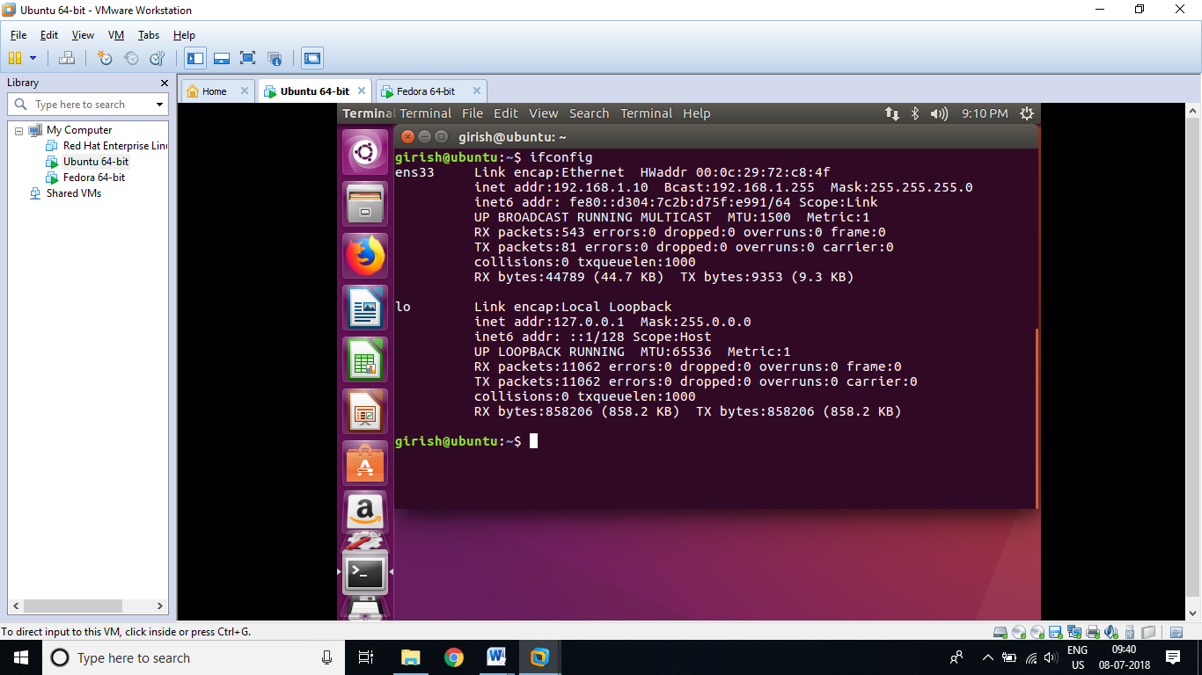

**Step 4.** Check status of DHCP server

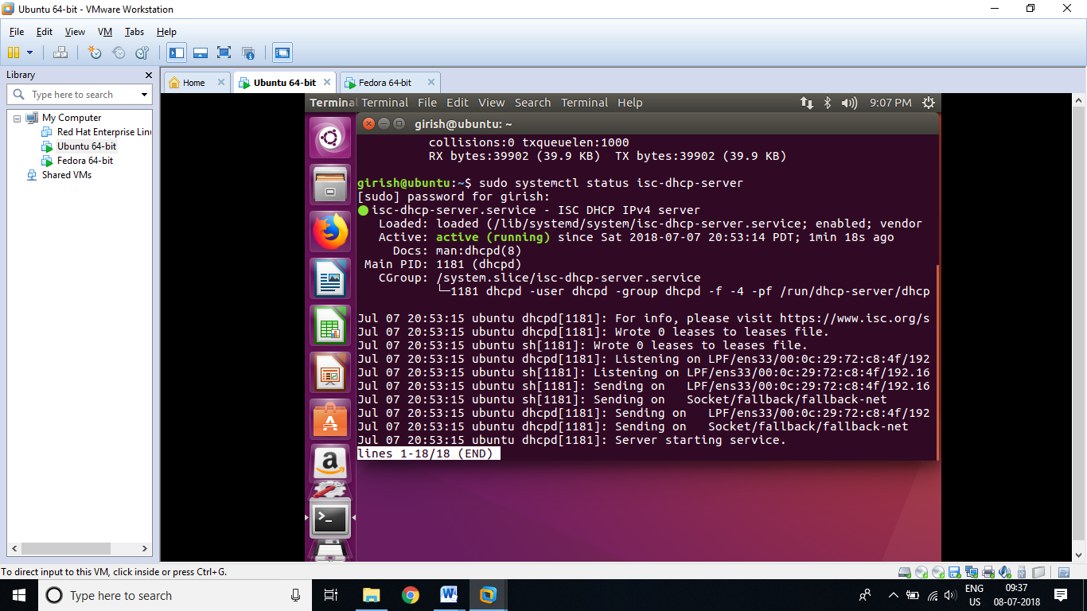

**Step 4.** Check status of Firewall (It must be inactive)

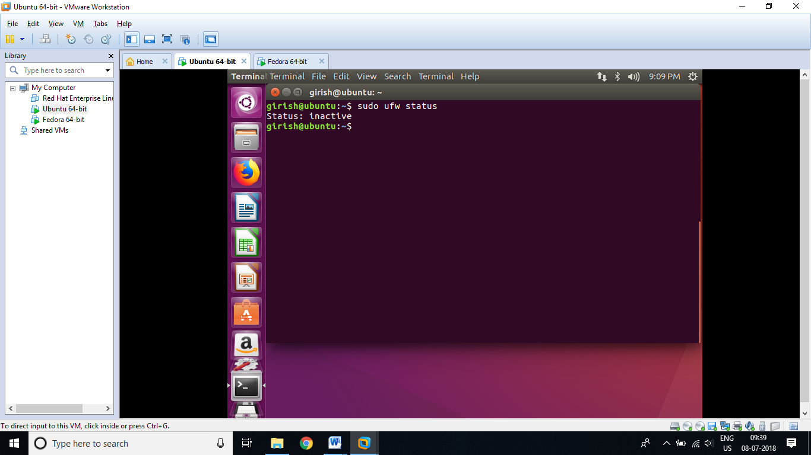

**Step 5.** Client Configuration (Client Machine is Fedora 28 Workstation)

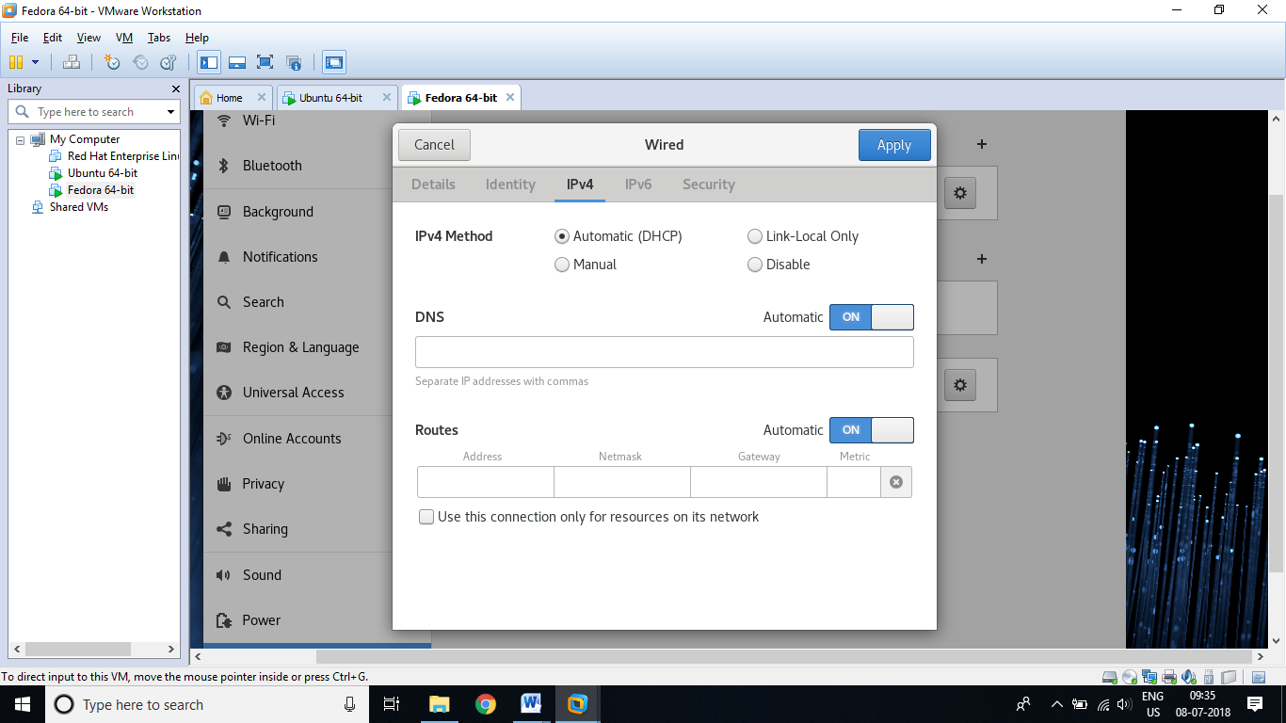

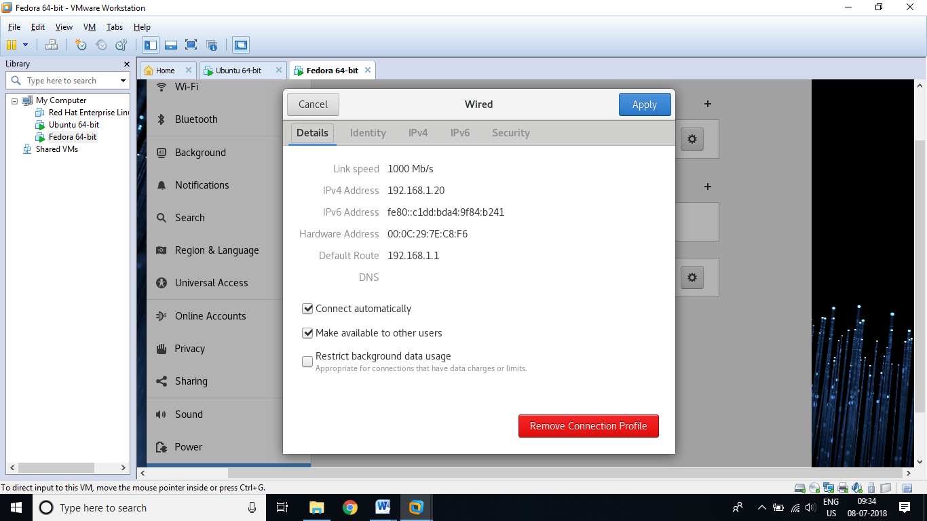

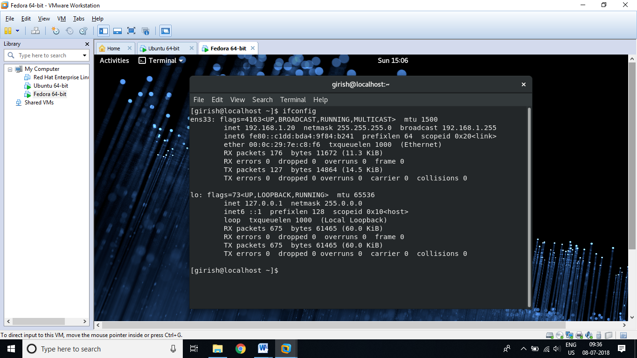

**Conclusion:**

DHCP Server, Ubuntu 16.04, leased IP address 192.168.1.20 to Fedora 28 Workstation.

**Imp. Note: While working on virtual machine, disable default DHCP Server in VMware or VirtualBox.**

Challenge: Try to allot fix IP address to particular MAC.

host ubuntu-client {

hardware ethernet 08:00:27:13:14:d5; Use correct MAC address of client m/c

fixed-address 192.168.1.30;

}

|  |
| --- |
| **Experiment 2: Initial Settings** Configure Networking on Ubuntu During the installation of Ubuntu on your server an IP address was most likely obtained automatically. This dynamic IP address assignment will need to be changed to a static IP address. This section will cover the simple network configuration changes needed to set a static IP network address for your server. For this section, the directions assume the configuration is for a node with only one interface (eth0) after a default installation.  ifconfig -a  Basic network configuration and hostname on a Ubuntu system are stored in several files which must be edited to create a working configuration:   * /etc/network/interfaces describes the network interfaces * /etc/hostname configures the nameserver credentials * /etc/hosts resolves IP addresses to hostnames   Once the new configuration is saved the interface must be restarted. Changing Network Configuration Below is an example of a static IP configuration on a system with only one Ethernet interface (eth0) and 10.0.0.41/24 for the IP address. Opening the /etc/network/interfaces file will produce:  # This file describes the network interfaces available on your system  # and how to activate them. For more information, see interfaces(5).  # The loopback network interface  auto lo  iface lo inet loopback  # The primary network interface  auto eth0  iface eth0 inet static  address 10.0.0.41  netmask 255.255.255.0  network 10.0.0.0  broadcast 10.0.0.255  gateway 10.0.0.1  dns-nameservers 10.0.0.1 8.8.8.8  dns-domain tcsc.org  dns-search tcsc.org  Open your /etc/network/interfaces file, locate the:   * "iface eth0..." line and change dynamic to static * address line and change the address to the static IP address * netmask line and change the address to the correct subnet mask * gateway line and change the address to the correct gateway address * dns-nameservers line and change (or add) the nameserver information   When you are happy with your configuration restart the interface with the command below. If you are connected using SSH you will lose your connection, re-connect using the new IP address:  ifdown eth0; ifup eth0 Changing the Hostname To change the hostname to your preferred node name (example: prodnode01), you have to edit the /etc/hostname file:  prodnode01 Adding the FQDN (Hostname) To ensure your server traffic will be routing correctly add the server's Fully Qualified Domain Name (FQDN) and IP address to the hosts file. Open the /etc/hosts file and add a line with the static IP address and the FQDN, similar to the example shown below:  192.168.0.0 prodnode01.tcsc.org  With all your files edited and saved, you should reboot so the new name and configuration will be used. Reboot the system and then use ifconfig or ipaddr to confirm that your new configuration is available. |

|  |  |
| --- | --- |
| [1] | Add a user (try with useradd command also) |

|  |
| --- |
| **# add a new user "ubuntu"**  **xerus@dlp:~$**  [**sudo**](https://www.server-world.info/en/command/html/sudo.html)[**adduser**](https://www.server-world.info/en/command/html/adduser.html)**ubuntu**  **[sudo] password for xerus:**  **# own password**  **Adding user `ubuntu' ... Adding new group `ubuntu' (1001) ... Adding new user `ubuntu' (1001) with group `ubuntu' ... Creating home directory `/home/ubuntu' ... Copying files from `/etc/skel' ... Enter new UNIX password:**  **# set password for new user**  **Retype new UNIX password:**  **# confirm**  **passwd: password updated successfully Changing the user information for ubuntu Enter the new value, or press ENTER for the default**  **Full Name []:**  **# if not need, Enter with empt**  **Room Number []:**  **Work Phone []:**  **Home Phone []:**  **Other []:**  **Is the information correct? [Y/n]**  **y**  **xerus@dlp:~$** |

|  |  |
| --- | --- |
| [2] | Giving privileges to a new user |

|  |
| --- |
| **xerus@dlp:~$**  [**sudo**](https://www.server-world.info/en/command/html/sudo.html)[**usermod**](https://www.server-world.info/en/command/html/usermod.html)**-G sudo ubuntu**  **xerus@dlp:~$**  [**su**](https://www.server-world.info/en/command/html/su.html)**- ubuntu**  **Password:**  **# try to execute a command which requires privilege**  **ubuntu@dlp:~$**  [**sudo**](https://www.server-world.info/en/command/html/sudo.html)[**reboot**](https://www.server-world.info/en/command/html/reboot.html)  **[sudo] password for ubuntu:**  **# password for 'ubuntu'**  **Broadcast message from xerus@dlp**  **(/dev/pts/0) at 19:59 ...**  **The system is going down for reboot NOW!** |

|  |
| --- |
| **Network Settings** |

|  |  |
| --- | --- |
| [1] | Change to static IP addres if you use Ubuntu as a server. "ens3" is different on each environment, replace it to your own one. |

|  |
| --- |
| **root@dlp:~#**  [**vi**](https://www.server-world.info/en/command/html/vi.html)**/etc/network/interfaces**  **# This file describes the network interfaces available on your system**  **# and how to activate them. For more information, see interfaces(5).**  **source /etc/network/interfaces.d/\***  **# The loopback network interface**  **auto lo**  **iface lo inet loopback**  **# The primary network interface**  **auto ens3**  **# comment out**  **#**  **iface ens3 inet dhcp**  **# add these lines**  **iface ens3 inet static address 10.0.0.30**  **# IP address**  **network 10.0.0.0**  **# network address**  **netmask 255.255.255.0**  **# subnet mask**  **broadcast 10.0.0.255**  **# broadcast address**  **gateway 10.0.0.1**  **# default gateway**  **dns-nameservers 10.0.0.10**  **# name server**  **# reboot once**  **root@dlp:~#**  **reboot** |

|  |  |
| --- | --- |
| [2] | Disable IPv6 if not needed. |

|  |
| --- |
| **root@dlp:~#**  [**echo**](https://www.server-world.info/en/command/html/echo.html)**"net.ipv6.conf.all.disable_ipv6 = 1" >> /etc/sysctl.conf**  **root@dlp:~#**  **sysctl -p**  **root@dlp:~#**  **ip addr**    **1: lo: <LOOPBACK,UP,LOWER_UP> mtu 65536 qdisc noqueue state UNKNOWN group default qlen 1**  **link/loopback 00:00:00:00:00:00 brd 00:00:00:00:00:00**  **inet 127.0.0.1/8 scope host lo**  **valid_lft forever preferred_lft forever**  **2: ens3: <BROADCAST,MULTICAST,UP,LOWER_UP> mtu 1500 qdisc pfifo_fast state UP group default qlen 1000**  **link/ether 52:54:00:ad:7d:9c brd ff:ff:ff:ff:ff:ff**  **inet 10.0.0.30/24 brd 10.0.0.255 scope global ens3**  **valid_lft forever preferred_lft forever** |

|  |
| --- |
| **Configure Services** |

|  |  |
| --- | --- |
| [1] | It's possible to make sure services' status like follows. |

|  |
| --- |
| **# display the list of services which are running**  **root@dlp:~#**  [**systemctl**](https://www.server-world.info/en/command/html/systemctl.html)**-t service**    **UNIT LOAD ACTIVE SUB DESCRIPTION**  **accounts-daemon.service loaded active running Accounts Service**  **apparmor.service loaded active exited LSB: AppArmor initialization**  **console-setup.service loaded active exited Set console keymap**  **cron.service loaded active running Regular background program pr**  **dbus.service loaded active running D-Bus System Message Bus**  **...**  **...**  **...**  **ufw.service loaded active exited Uncomplicated firewall**  **user@0.service loaded active running User Manager for UID 0**  **LOAD = Reflects whether the unit definition was properly loaded.**  **ACTIVE = The high-level unit activation state, i.e. generalization of SUB.**  **SUB = The low-level unit activation state, values depend on unit type.**  **35 loaded units listed. Pass --all to see loaded but inactive units, too.**  **To show all installed unit files use 'systemctl list-unit-files'.**  **# the list of all services**  **root@dlp:~#**  [**systemctl**](https://www.server-world.info/en/command/html/systemctl.html)**list-unit-files -t service**    **UNIT FILE STATE**  **accounts-daemon.service enabled**  **apt-daily.service static**  **autovt@.service enabled**  **bootlogd.service masked**  **...**  **...**  **...**  **user@.service static**  **uuidd.service indirect**  **x11-common.service masked**  **144 unit files listed.** |

|  |  |
| --- | --- |
| [2] | Stop and turn OFF auto-start setting for a service if you don'd need it. (it's Apparmor as an example below) |

|  |
| --- |
| **root@dlp:~#**  [**systemctl**](https://www.server-world.info/en/command/html/systemctl.html)**stop apparmor**  **root@dlp:~#**  [**systemctl**](https://www.server-world.info/en/command/html/systemctl.html)**disable apparmor** |

|  |
| --- |
| **Sudo Settings** |

|  |  |
| --- | --- |
|  | Configure Sudo to separate users' duty if some people share privileges. |
| [1] | Install Sudo. |

|  |
| --- |
| **root@dlp:~#**  [**apt-get**](https://www.server-world.info/en/command/html/apt-get.html)**-y install sudo** |

|  |  |
| --- | --- |
| [2] | Transfer root privilege to a user all. |

|  |
| --- |
| **root@dlp:~#**  [**visudo**](https://www.server-world.info/en/command/html/visudo.html)  **# add to the end: user 'xerus' can use all root privilege**  **xerus ALL=(ALL:ALL) ALL**  **# how to write ⇒ destination host=(owner) command**  **# push 'Ctrl + x' key to quit visudo**  **# verify with user 'xerus'**  **xerus@dlp:~$**  **/sbin/**[**shutdown**](https://www.server-world.info/en/command/html/shutdown.html)**-r now**  **shutdown: Need to be root**  **# denied normally**  **xerus@dlp:~$**  [**sudo**](https://www.server-world.info/en/command/html/sudo.html)**/sbin/**[**shutdown**](https://www.server-world.info/en/command/html/shutdown.html)**-r now**  **[sudo] password for xerus:**  **# xerus's password**  **Broadcast message from root@dlp**  **(/dev/pts/0) at 17:33 ...**  **The system is going down for reboot NOW!**  **# executed** |

|  |  |
| --- | --- |
| [3] | In addition to the setting [1], set that some commands are not allowed. |

|  |
| --- |
| **root@dlp:~#**  [**visudo**](https://www.server-world.info/en/command/html/visudo.html)  **# add alias for the kind of shutdown commands**  **# Cmnd alias specification**  **Cmnd_Alias SHUTDOWN = /sbin/halt, /sbin/shutdown, \ /sbin/poweroff, /sbin/reboot, /sbin/init**  **# add ( commands in alias 'SHUTDOWN' are not allowed )**  **xerus     ALL=(ALL)     ALL,**  **!SHUTDOWN**  **# verify with user 'xerus'**  **xerus@dlp:~$**  [**sudo**](https://www.server-world.info/en/command/html/sudo.html)**/sbin/**[**shutdown**](https://www.server-world.info/en/command/html/shutdown.html)**-r now**  **[sudo] password for xerus: Sorry, user xerus is not allowed to execute '/sbin/shutdown -r now' as root on dlp.server.world.**  **# denied normally** |

|  |  |
| --- | --- |
| [4] | Transfer some commands with root privilege to users in a group. |

|  |
| --- |
| **root@dlp:~#**  [**visudo**](https://www.server-world.info/en/command/html/visudo.html)  **# add aliase for the kind of user management comamnds**  **# Cmnd alias specification**  **Cmnd_Alias USERMGR = /usr/sbin/adduser, /usr/sbin/useradd, /usr/sbin/newusers, \ /usr/sbin/deluser, /usr/sbin/userdel, /usr/sbin/usermod, /usr/bin/passwd**  **# add to the end**  **%usermgr ALL=(ALL) USERMGR**  **root@dlp:~#**  [**groupadd**](https://www.server-world.info/en/command/html/groupadd.html)**usermgr**  **root@dlp:~#**  [**vi**](https://www.server-world.info/en/command/html/vi.html)**/etc/group**  **# add a user in this group**  **usermgr:x:1002:**  **xerus**  **# verify with user 'xerus'**  **xerus@dlp:~$**  [**sudo**](https://www.server-world.info/en/command/html/sudo.html)**/usr/sbin/**[**useradd**](https://www.server-world.info/en/command/html/useradd.html)**testuser**  **xerus@dlp:~$**  **# done normally**  **xerus@dlp:~$**  [**sudo**](https://www.server-world.info/en/command/html/sudo.html)**/usr/bin/**[**passwd**](https://www.server-world.info/en/command/html/passwd.html)**testuser**  **Enter new UNIX password:**  **# set testuser's password**  **Retype new UNIX password: passwd: password updated successfully** |

|  |  |
| --- | --- |
| [5] | Transfer some commands with root privilege to a user. |

|  |
| --- |
| **root@dlp:~#**  [**visudo**](https://www.server-world.info/en/command/html/visudo.html)  **# add to the end**  **fedora     ALL=(ALL) /usr/sbin/visudo cent     ALL=(ALL) /usr/sbin/adduser, /usr/sbin/useradd, /usr/sbin/newusers, \     /usr/sbin/deluser, /usr/sbin/userdel, /usr/sbin/usermod, /usr/bin/passwd suse     ALL=(ALL) /usr/bin/vim**  **# verify with user 'fedora'**  **fedora@dlp:~$**  [**sudo**](https://www.server-world.info/en/command/html/sudo.html)**/usr/sbin/**[**visudo**](https://www.server-world.info/en/command/html/visudo.html)  **# possible to open and edit**  **## Sudoers allows particular users to run various commands as ## the root user, without needing the root password. ##**  **# verify with user 'cent'**  **cent@dlp:~$**  [**sudo**](https://www.server-world.info/en/command/html/sudo.html)**/usr/sbin/**[**userdel**](https://www.server-world.info/en/command/html/userdel.html)**-r testuser**  **cent@dlp:~$**  **# done normally**  **# verify with user 'suse'**  **suse@dlp:~$**  [**sudo**](https://www.server-world.info/en/command/html/sudo.html)**/usr/bin/**[**vim**](https://www.server-world.info/en/command/html/vi.html)**/root/.profile**  **# possible to edit or save**  **# ~/.profile: executed by Bourne-compatible login shells.** |

|  |  |
| --- | --- |
| [6] | The logs for sudo are kept in '/var/log/auth.log', but there are many kind of logs in it. So if you'd like to keep only sudo's log in a file, Set like follows. |

|  |
| --- |
| **root@dlp:~#**  [**visudo**](https://www.server-world.info/en/command/html/visudo.html)  **# add to the end**  **Defaults syslog=local1**  **root@dlp:~#**  [**vi**](https://www.server-world.info/en/command/html/vi.html)**/etc/rsyslog.d/50-default.conf**  **# line 8: add**  **local1.* /var/log/sudo.log**  **auth,authpriv.* /var/log/auth.log**  **\*.*;auth,authpriv.none -/var/log/syslog**  **root@dlp:~#**  [**systemctl**](https://www.server-world.info/en/command/html/systemctl.html)**restart rsyslog** |

|  |
| --- |
| **Update System** |

|  |  |
| --- | --- |
| [1] | Update System. |

|  |
| --- |
| **# Update List first**  **root@dlp:~#**  [**apt-get**](https://www.server-world.info/en/command/html/apt-get.html)**update**    **Hit http://jp.archive.ubuntu.com/ubuntu xenial InRelease**  **Get: 1 http://jp.archive.ubuntu.com/ubuntu xenial-updates InRelease [92.2 kB]**  **Hit http://jp.archive.ubuntu.com/ubuntu xenial-backports InRelease**  **Get: 2 http://jp.archive.ubuntu.com/ubuntu xenial-updates/main amd64 Packages [3,312 B]**  **Get: 3 http://jp.archive.ubuntu.com/ubuntu xenial-updates/main i386 Packages [3,324 B]**  **Get: 4 http://jp.archive.ubuntu.com/ubuntu xenial-updates/main Translation-en [2,012 B]**  **Get: 5 http://jp.archive.ubuntu.com/ubuntu xenial-updates/universe amd64 Packages [2,688 B]**  **Get: 6 http://jp.archive.ubuntu.com/ubuntu xenial-updates/universe i386 Packages [2,680 B]**  **Get: 7 http://jp.archive.ubuntu.com/ubuntu xenial-updates/universe Translation-en [2,000 B]**  **Get: 8 http://security.ubuntu.com/ubuntu xenial-security InRelease [92.2 kB]**  **Get: 9 http://security.ubuntu.com/ubuntu xenial-security/main amd64 Packages [632 B]**  **Get: 10 http://security.ubuntu.com/ubuntu xenial-security/main i386 Packages [632 B]**  **Get: 11 http://security.ubuntu.com/ubuntu xenial-security/main Translation-en [376 B]**  **Fetched 202 kB in 1s (112 kB/s)**  **Current status: 1 (+1) upgradable.**  **root@dlp:~#**  [**apt-get**](https://www.server-world.info/en/command/html/apt-get.html)**-y upgrade** |

Important files in Ubuntu:

* /etc/network/interfaces describes the network interfaces
* /etc/hostname configures the nameserver credentials
* /etc/hosts resolves IP addresses to hostnames

|  |
| --- |
| **Experiment 3: Configure NTP Server (NTPd)**  **(Ref. https://www.server-world.info/en/note?os=Ubuntu_16.04&p=ntp&f=1)**  **Time Synchronisation**  NTP is a TCP/IP protocol for synchronising time over a network. Basically a client requests the current time from a server, and uses it to set its own clock. |

|  |  |
| --- | --- |
|  | Install NTPd and Configure NTP server for time adjustment. NTP uses 123/UDP. |
| [1] | Install and Configure NTPd. |

|  |
| --- |
| **root@dlp:~#**  [**apt-get**](https://www.server-world.info/en/command/html/apt-get.html)**-y install ntp**  **root@dlp:~#**  [**vi**](https://www.server-world.info/en/command/html/vi.html)**/etc/ntp.conf**  **# line 18: omment out**  **#**  **pool 0.ubuntu.pool.ntp.org iburst**  **#**  **pool 1.ubuntu.pool.ntp.org iburst**  **#**  **pool 2.ubuntu.pool.ntp.org iburst**  **#**  **pool 3.ubuntu.pool.ntp.org iburst**  **#**  **pool ntp.ubuntu.com**  **# add servers of your timezone for time synchronization**  **server ntp1.jst.mfeed.ad.jp iburst  server ntp2.jst.mfeed.ad.jp iburst  server ntp3.jst.mfeed.ad.jp iburst**  **# line 50: add the network range you allow to receive requests**  **restrict 10.0.0.0 mask 255.255.255.0 nomodify notrap**  **root@dlp:~#**  [**systemctl**](https://www.server-world.info/en/command/html/systemctl.html)**restart ntp**  **# show status**  **root@dlp:~#**  [**ntpq**](https://www.server-world.info/en/command/html/ntpq.html)**-p**    **remote refid st t when poll reach delay offset jitter**  **==============================================================================**  **\*ntp1.jst.mfeed. 133.243.236.17 2 u 8 64 3 17.613 3.116 2.670**  **ntp2.jst.mfeed. .INIT. 16 u - 64 0 0.000 0.000 0.000**  **+ntp3.jst.mfeed. 133.243.236.17 2 u 3 64 3 18.134 2.303 3.591** |

|  |
| --- |
| **Configure NTP Client : Ubuntu** |

|  |  |
| --- | --- |
|  | Configure NTP Client. |
| [1] | The settings of NTP Client on Ubuntu are mostly the same with Server's settings, so refer to [NTPd Settings](https://www.server-world.info/en/note?os=Ubuntu_16.04&p=ntp&f=1) or [Chrony Settings](https://www.server-world.info/en/note?os=Ubuntu_16.04&p=ntp&f=2). For different settings from Server's one, Clients don't need to receive time synchronization requests from other computers, so it does not need to set access permission. |
| [2] | If you don't use NTP service daemon but use a command to sync time at once, use ntpdate like follows. |

|  |
| --- |
| **root@client:~#**  [**apt-get**](https://www.server-world.info/en/command/html/apt-get.html)**-y install ntpdate**  **root@client:~#**  **ntpdate ntp1.jst.mfeed.ad.jp**  **21 Apr 19:41:26 ntpdate[1458]: step time server 210.173.160.27 offset 0.667927 sec** |

|  |
| --- |
| **Configure NTP Client : Windows** |

|  |  |
| --- | --- |
|  | Configure NTP Client on Windows. This example is based on Windows 10 Pro. |

|  |  |
| --- | --- |
| [3] | Open [Control Panel] - [Date and Time] and move to [internet Time] tab, then [Change settings] button. |

|  |
| --- |
| https://www.server-world.info/en/Ubuntu_16.04/ntp/img/2.png |

|  |  |
| --- | --- |
| [4] | Input NTP server you'd like to sync on [Server] section and [Update now] button. |

|  |
| --- |
| https://www.server-world.info/en/Ubuntu_16.04/ntp/img/3.png |

|  |  |
| --- | --- |
| [5] | It's OK to sync time if successuful message is shown like follows. The default setting of sync interval is 86400 sec (one day).  HKEY_LOCAL_MACHINE\SYSTEM\CurrentControlSet\Services\W32Time\ TimeProviders\NtpClient\SpecialPollInterval |

|  |
| --- |
| https://www.server-world.info/en/Ubuntu_16.04/ntp/img/4.png |

|  |  |
| --- | --- |
| [6] | If you'd like to configure NTP Client Service, Set like follows.  Right-click Windows icon and open [run] and input "gpedit.msc" like follows. |

|  |
| --- |
| https://www.server-world.info/en/Ubuntu_16.04/ntp/img/5.png |

|  |  |
| --- | --- |
| [7] | Select [Administrative template] - [System] - [Windows Time Service] - [Time Providers] on the left Pane, and Open [Enable Windows NTP Client] on the right Pane. |

|  |
| --- |
| https://www.server-world.info/en/Ubuntu_16.04/ntp/img/6.png |

|  |  |
| --- | --- |
| [8] | Check a box [Enabled] which is upper-left like follows. |

|  |
| --- |
| https://www.server-world.info/en/Ubuntu_16.04/ntp/img/7.png |

|  |  |
| --- | --- |
| [9] | Click to open [Configure Windows NTP Client] on the right Pane. |

|  |
| --- |
| https://www.server-world.info/en/Ubuntu_16.04/ntp/img/6.png |

|  |  |
| --- | --- |
| [10] | Check a box [Enabled] which is upper-left and change values for your environment.  [NtpServer] ⇒ Hostname or IP address of your NTP Server. The value [0x9] is generally OK to keep default. [0x9] means [0x01] + [0x08]. They mean like follows.  0x01 SpecialInterval 0x02 UseAsFallbackOnly 0x04 SymmetricActive 0x08 NTP request in Client mode  For [Type] section, It's OK to keep default [NT5DS] if your computer is in a Domain, but if not, change to [NTP]. For [SpecialPollInterval], set interval to sync time. |

|  |
| --- |
| https://www.server-world.info/en/Ubuntu_16.04/ntp/img/8.png |

|  |  |
| --- | --- |
| [11] | Open [Control Panale] - [Administrative tools] - [Services], then Select [Windows Time] Service and click [Start the service] or [Restart the service]. Furthermore, Change [Startup type] to [Automatic] if it is not the value. |

|  |
| --- |
| https://www.server-world.info/en/Ubuntu_16.04/ntp/img/9.png |

|  |
| --- |
| **Experiment 4: SSH Server : Password Authentication**  (Ref: https://www.server-world.info/en/note?os=Ubuntu_16.04&p=ssh&f=1)  Introduction:  This section of the Ubuntu Server Guide introduces a powerful collection of tools for the remote control of, and transfer of data between, networked computers called *OpenSSH*. You will also learn about some of the configuration settings possible with the OpenSSH server application and how to change them on your Ubuntu system.  OpenSSH is a freely available version of the Secure Shell (SSH) protocol family of tools for remotely controlling, or transferring files between, computers. Traditional tools used to accomplish these functions, such as telnet or rcp, are insecure and transmit the user's password in cleartext when used. OpenSSH provides a server daemon and client tools to facilitate secure, encrypted remote control and file transfer operations, effectively replacing the legacy tools. |

|  |  |
| --- | --- |
|  | Configure SSH Server to manage a server from the remore computer. SSH uses 22/TCP. |
| [1] | Password Authentication for Open SSH Server on Ubuntu is enabled by default, so it's possible to login without changing any settings. Furthermore, root account is prohibited Password Authentication by default with "PermitRootLogin prohibit-password", so default setting is good for use. But if you prohibit root login all, change like follows. |

|  |
| --- |
| **root@dlp:~#**  [**apt-get**](https://www.server-world.info/en/command/html/apt-get.html)**-y install openssh-server**  **root@dlp:~#**  [**vi**](https://www.server-world.info/en/command/html/vi.html)**/etc/ssh/sshd_config**  **# line 28: change to no**  **PermitRootLogin**  **no**  **root@dlp:~#**  [**systemctl**](https://www.server-world.info/en/command/html/systemctl.html)**restart ssh** |

|  |
| --- |
| **SSH Client : Ubuntu : Ubuntu** |

|  |  |
| --- | --- |
|  | Configure SSH Client for Ubuntu. |
| [2] | Install SSH Client. |

|  |
| --- |
| **root@client:~#**  [**apt-get**](https://www.server-world.info/en/command/html/apt-get.html)**-y install openssh-client** |

|  |  |
| --- | --- |
| [3] | Connect to the SSH server with a common user. |

|  |
| --- |
| **# ssh [username@hostname or IP address]**  **root@client:~#**  **ssh ubuntu@dlp.srv.world**  **The authenticity of host 'dlp.srv.world (<no hostip for proxy command>)' can't be established. ECDSA key fingerprint is xx:xx:xx:xx:xx:xx:xx:xx:xx:xx:xx:xx:xx:60:90:d8. Are you sure you want to continue connecting (yes/no)?**  **yes**  **Warning: Permanently added 'dlp.srv.world' (ECDSA) to the list of known hosts. ubuntu@dlp.srv.world's password:**  **# password of the user**  **ubuntu@dlp:~$**  **# just logined** |

|  |  |
| --- | --- |
| [4] | It's possbile to execute commands on remote Host with adding commands to ssh command. |

|  |
| --- |
| **# for example, open /etc/passwd on remote host**  **ubuntu@client:~$**  **ssh ubuntu@dlp.srv.world "cat /etc/passwd"**  **ubuntu@dlp.srv.world's password:**  **root:x:0:0:root:/root:/bin/bash**  **daemon:x:1:1:daemon:/usr/sbin:/usr/sbin/nologin**  **...**  **...**  **ubuntu:x:1000:1000:ubuntu,,,:/home/ubuntu:/bin/bash**  **sshd:x:108:65534::/var/run/sshd:/usr/sbin/nologin** |

|  |
| --- |
| **SSH Client : Windows** |

|  |  |
| --- | --- |
|  | Configure SSH Client for Windows. |
| [5] | Get a SSH Client for Windows. This example shows to use [Putty](http://www.chiark.greenend.org.uk/~sgtatham/putty/) like follows.  Input your server's IP address and Click 'Open' button. |

|  |
| --- |
| https://www.server-world.info/en/Ubuntu_16.04/ssh/img/1.png |

|  |  |
| --- | --- |
| [6] | After authentication on SSH server, it's possible to login remotely with SSH. |

|  |
| --- |
| https://www.server-world.info/en/Ubuntu_16.04/ssh/img/2.png |

|  |
| --- |
| **Experiment 5: Install BIND**  (Ref <https://www.server-world.info/en/note?os=Ubuntu_16.04&p=dns&f=1>)  Domain Name Service (DNS) is an Internet service that maps IP addresses and fully qualified domain names (FQDN) to one another. In this way, DNS alleviates the need to remember IP addresses. Computers that run DNS are called name servers. Ubuntu ships with BIND (Berkley Internet Naming Daemon), the most common program used for maintaining a name server on Linux. A very useful package for testing and troubleshooting DNS issues is the dnsutils package.  Overview  The DNS configuration files are stored in the /etc/bind directory. The primary configuration file is /etc/bind/named.conf.  The *include* line specifies the filename which contains the DNS options. The *directory* line in the /etc/bind/named.conf.options file tells DNS where to look for files. All files BIND uses will be relative to this directory.  The file named /etc/bind/db.root describes the root nameservers in the world. The servers change over time, so the /etc/bind/db.root file must be maintained now and then. This is usually done as updates to the bind9 package. The *zone* section defines a master server, and it is stored in a file mentioned in the *file* option.  It is possible to configure the same server to be a caching name server, primary master, and secondary master. A server can be the Start of Authority (SOA) for one zone, while providing secondary service for another zone. All the while providing caching services for hosts on the local LAN. |

|  |  |
| --- | --- |
|  | Configure DNS server which resolves domain name or IP address.  BIND uses 53/TCP, UDP |
| [1] | Install BIND 9 |

|  |
| --- |
| **root@dlp:~#**  [**apt-get**](https://www.server-world.info/en/command/html/apt-get.html)**-y install bind9 bind9utils** |

|  |  |
| --- | --- |
| [2] | Configure BIND. This example is set with grobal IP address [172.16.0.80/29], Private IP address [10.0.0.0/24], Domain name [srv.world]. However, Please use your own IPs and domain name when you set config on your server. (Actually, [172.16.0.80/29] is for private IP address, though.) |

|  |
| --- |
| **root@dlp:~#**  [**vi**](https://www.server-world.info/en/command/html/vi.html)**/etc/bind/named.conf**  **include "/etc/bind/named.conf.options"; include "/etc/bind/named.conf.local";**  **# comment out**  **#**  **include "/etc/bind/named.conf.default-zones";**  **# add**  **include "/etc/bind/named.conf.internal-zones";**  **include "/etc/bind/named.conf.external-zones";**  **root@dlp:~#**  [**vi**](https://www.server-world.info/en/command/html/vi.html)**/etc/bind/named.conf.internal-zones**  **# create new**  **# define for internal section**  **view "internal" {**  **match-clients {**  **localhost;**  **10.0.0.0/24;**  **};**  **# set zone for internal**    **zone "srv.world" {**  **type master;**  **file "/etc/bind/srv.world.lan";**  **allow-update { none; };**  **};**  **# set zone for internal *note**    **zone "0.0.10.in-addr.arpa" {**  **type master;**  **file "/etc/bind/0.0.10.db";**  **allow-update { none; };**  **};**  **include "/etc/bind/named.conf.default-zones";**  **};**  **root@dlp:~#**  [**vi**](https://www.server-world.info/en/command/html/vi.html)**/etc/bind/named.conf.external-zones**  **# create new**  **# define for external section**  **view "external" {**  **# define for external section**    **match-clients { any; };**  **# allow any query**    **allow-query { any; };**  **# prohibit recursions**    **recursion no;**  **# set zone for external**    **zone "srv.world" {**  **type master;**  **file "/etc/bind/srv.world.wan";**  **allow-update { none; };**  **};**  **# set zone for external *note**    **zone "80.0.16.172.in-addr.arpa" {**  **type master;**  **file "/etc/bind/80.0.16.172.db";**  **allow-update { none; };**  **};**  **};**  **# *note : For How to write for reverse resolving, Write network address reversely like below**  **# 10.0.0.0/24**  **# network address ⇒ 10.0.0.0**  **# range of network ⇒ 10.0.0.0 - 10.0.0.255**  **# how to write ⇒ 0.0.10.in-addr.arpa**  **# 172.16.0.80/29**  **# network address ⇒ 172.16.0.80**  **# range of network ⇒ 172.16.0.80 - 172.16.0.87**  **# how to write ⇒ 80.0.16.172.in-addr.arpa** |

|  |  |
| --- | --- |
| [3] | Limit ranges you allow to access if needed. |

|  |
| --- |
| **root@dlp:~#**  [**vi**](https://www.server-world.info/en/command/html/vi.html)**/etc/bind/named.conf.options**  **options {**  **directory "/var/cache/bind";**  **// If there is a firewall between you and nameservers you want**  **// to talk to, you may need to fix the firewall to allow multiple**  **// ports to talk. See http://www.kb.cert.org/vuls/id/800113**  **// If your ISP provided one or more IP addresses for stable**  **// nameservers, you probably want to use them as forwarders.**  **// Uncomment the following block, and insert the addresses replacing**  **// the all-0's placeholder.**  **// forwarders {**  **//       0.0.0.0;**  **// };**  **# query range you allow**  **allow-query { localhost; 10.0.0.0/24; };**  **# the range to transfer zone files**  **allow-transfer { localhost; 10.0.0.0/24; };**  **# recursion range you allow**  **allow-recursion { localhost; 10.0.0.0/24; };**  **dnssec-validation auto;**  **auth-nxdomain no; # conform to RFC1035**  **# change if not use IPV6**  **listen-on-v6**  **{ none; };**  **};** |

|  |
| --- |
| **Name Resolution** |

|  |  |
| --- | --- |
|  | Create zone files that servers resolve IP address from domain name. |
|  | |
| [1] | For internal zone, This example uses internal address [10.0.0.0/24], domain name [srv.world], but please use your own one when you set config on your server. |

|  |
| --- |
| **root@dlp:~#**  [**vi**](https://www.server-world.info/en/command/html/vi.html)**/etc/bind/srv.world.lan**  **$TTL 86400**  **@ IN SOA dlp.srv.world. root.srv.world. (**  **2016042101 ;Serial**  **3600 ;Refresh**  **1800 ;Retry**  **604800 ;Expire**  **86400 ;Minimum TTL**  **)**  **# define name server**    **IN NS dlp.srv.world.**  **# define name server's IP address**    **IN A 10.0.0.30**  **# define mail exchanger**    **IN MX 10 dlp.srv.world.**  **# define IP address of a hostname**    **dlp IN A 10.0.0.30** |

|  |  |
| --- | --- |
| [2] | For external zone, This example uses external address [172.16.0.80/29], domain name [srv.world], but please use your own one when you set config on your server. |

|  |
| --- |
| **root@dlp:~#**  [**vi**](https://www.server-world.info/en/command/html/vi.html)**/etc/bind/srv.world.wan**  **$TTL 86400**  **@ IN SOA dlp.srv.world. root.srv.world. (**  **2016042101 ;Serial**  **3600 ;Refresh**  **1800 ;Retry**  **604800 ;Expire**  **86400 ;Minimum TTL**  **)**  **# define name server**    **IN NS dlp.srv.world.**  **# define name server's IP address**    **IN A 172.16.0.82**  **# define mail exchanger**    **IN MX 10 dlp.srv.world.**  **# define IP address of a hostname**    **dlp IN A 172.16.0.82** |

|  |
| --- |
| **Address Resolution** |

|  |  |
| --- | --- |
|  | Create zone files that servers resolve domain names from IP address. |
|  | |
| [3] | For internal zone, This example uses internal address [10.0.0.0/24], domain name [srv.world], but please use your own one when you set config on your server. |

|  |
| --- |
| **root@dlp:~#**  [**vi**](https://www.server-world.info/en/command/html/vi.html)**/etc/bind/0.0.10.db**  **$TTL 86400**  **@ IN SOA dlp.srv.world. root.srv.world. (**  **2016042101 ;Serial**  **3600 ;Refresh**  **1800 ;Retry**  **604800 ;Expire**  **86400 ;Minimum TTL**  **)**  **# define name server**    **IN NS dlp.srv.world.**  **# define the range of this domain included**    **IN PTR srv.world.**  **IN A 255.255.255.0**  **# define hostname of an IP address**    **30 IN PTR dlp.srv.world.** |

|  |  |
| --- | --- |
| [4] | For external zone, This example uses external address [172.16.0.80/29], domain name [srv.world], but please use your own one when you set config on your server. |

|  |
| --- |
| **root@dlp:~#**  [**vi**](https://www.server-world.info/en/command/html/vi.html)**/etc/bind/80.0.16.172.db**  **$TTL 86400**  **@ IN SOA dlp.srv.world. root.srv.world. (**  **2016042101 ;Serial**  **3600 ;Refresh**  **1800 ;Retry**  **604800 ;Expire**  **86400 ;Minimum TTL**  **)**  **# define name server**    **IN NS dlp.srv.world.**  **# define the range of this domain included**    **IN PTR srv.world.**  **IN A 255.255.255.248**  **# define hostname of an IP address**    **82 IN PTR dlp.srv.world.** |

|  |
| --- |
| **Start BIND** |

|  |  |
| --- | --- |
|  | Restart BIND to take effect changes and make sure it's no ploblem. |
| [1] | Change resolv.conf for name resolution to refer to own DNS. ("ens3" is different on each environment, Replace it to your own one) |

|  |
| --- |
| **root@dlp:~#**  [**vi**](https://www.server-world.info/en/command/html/vi.html)**/etc/network/interfaces**  **# change to own one**  **dns-nameservers**  **10.0.0.30**  **root@dlp:~#**  [**systemctl**](https://www.server-world.info/en/command/html/systemctl.html)**restart ifup@ens3 bind9** |

|  |  |
| --- | --- |
| [2] | Try to resolv normally. |

|  |
| --- |
| **root@dlp:~#**  [**dig**](https://www.server-world.info/en/command/html/dig.html)**dlp.srv.world.**    **; <<>> DiG 9.10.3-P4-Ubuntu <<>> dlp.srv.world.**  **;; global options: +cmd**  **;; Got answer:**  **;; ->>HEADER<<- opcode: QUERY, status: NOERROR, id: 30428**  **;; flags: qr aa rd ra; QUERY: 1, ANSWER: 1, AUTHORITY: 1, ADDITIONAL: 1**  **;; OPT PSEUDOSECTION:**  **; EDNS: version: 0, flags:; udp: 4096**  **;; QUESTION SECTION:**  **;dlp.srv.world. IN A**  **;; ANSWER SECTION:**  **dlp.srv.world. 86400 IN A 10.0.0.30**  **;; AUTHORITY SECTION:**  **srv.world. 86400 IN NS dlp.srv.world.**  **;; Query time: 0 msec**  **;; SERVER: 10.0.0.30#53(10.0.0.30)**  **;; WHEN: Fri Apr 22 17:08:09 JST 2016**  **;; MSG SIZE rcvd: 75**  **root@dlp:~#**  [**dig**](https://www.server-world.info/en/command/html/dig.html)**-x 10.0.0.30**    **; <<>> DiG 9.10.3-P4-Ubuntu <<>> -x 10.0.0.30**  **;; global options: +cmd**  **;; Got answer:**  **;; ->>HEADER<<- opcode: QUERY, status: NOERROR, id: 41939**  **;; flags: qr aa rd ra; QUERY: 1, ANSWER: 1, AUTHORITY: 1, ADDITIONAL: 2**  **;; OPT PSEUDOSECTION:**  **; EDNS: version: 0, flags:; udp: 4096**  **;; QUESTION SECTION:**  **;30.0.0.10.in-addr.arpa. IN PTR**  **;; ANSWER SECTION:**  **30.0.0.10.in-addr.arpa. 86400 IN PTR dlp.srv.world.**  **;; AUTHORITY SECTION:**  **0.0.10.in-addr.arpa. 86400 IN NS dlp.srv.world.**  **;; ADDITIONAL SECTION:**  **dlp.srv.world. 86400 IN A 10.0.0.30**  **;; Query time: 0 msec**  **;; SERVER: 10.0.0.30#53(10.0.0.30)**  **;; WHEN: Fri Apr 22 17:10:15 JST 2016**  **;; MSG SIZE rcvd: 111** |

|  |
| --- |
| **Set CNAME** |

|  |  |
| --- | --- |
|  | If you'd like to set another name to your Host, define CNAME record in zone file. |
| [1] | Set CNAME record in zone file. |

|  |
| --- |
| **root@dlp:~#**  [**vi**](https://www.server-world.info/en/command/html/vi.html)**/etc/bind/srv.world.lan**  **$TTL 86400**  **@ IN SOA dlp.srv.world. root.srv.world. (**  **# update serial**    **2016042102 ;Serial**  **3600 ;Refresh**  **1800 ;Retry**  **604800 ;Expire**  **86400 ;Minimum TTL**  **)**  **IN NS dlp.srv.world.**  **IN A 10.0.0.30**  **IN MX 10 dlp.srv.world.**  **dlp IN A 10.0.0.30**  **# aliase IN CNAME server's name**  **ftp IN CNAME dlp.srv.world.**  **root@dlp:~#**  [**rndc**](https://www.server-world.info/en/command/html/rndc.html)**reload**  **server reload successful**  **root@dlp:~#**  [**dig**](https://www.server-world.info/en/command/html/dig.html)**ftp.srv.world.**    **; <<>> DiG 9.10.3-P4-Ubuntu <<>> ftp.srv.world.**  **;; global options: +cmd**  **;; Got answer:**  **;; ->>HEADER<<- opcode: QUERY, status: NOERROR, id: 41265**  **;; flags: qr aa rd ra; QUERY: 1, ANSWER: 2, AUTHORITY: 1, ADDITIONAL: 1**  **;; OPT PSEUDOSECTION:**  **; EDNS: version: 0, flags:; udp: 4096**  **;; QUESTION SECTION:**  **;ftp.srv.world. IN A**  **;; ANSWER SECTION:**  **ftp.srv.world. 86400 IN CNAME dlp.srv.world.**  **dlp.srv.world. 86400 IN A 10.0.0.30**  **;; AUTHORITY SECTION:**  **srv.world. 86400 IN NS dlp.srv.world.**  **;; Query time: 0 msec**  **;; SERVER: 10.0.0.30#53(10.0.0.30)**  **;; WHEN: Fri Apr 22 17:16:13 JST 2016**  **;; MSG SIZE rcvd: 93** |

|  |
| --- |
| **Slave DNS Server** |

|  |  |
| --- | --- |
|  | Configure BIND as a Slave DNS Server.  The following example shows an environment that master DNS is "172.16.0.82", Slave DNS is "slave.example.host". |
| [1] | Configure DNS master server. |

|  |
| --- |
| **root@dlp:~#**  [**vi**](https://www.server-world.info/en/command/html/vi.html)**/etc/bind/named.conf.options**  **options {**  **directory "/etc/bind";**  **// If there is a firewall between you and nameservers you want**  **// to talk to, you may need to fix the firewall to allow multiple**  **// ports to talk. See http://www.kb.cert.org/vuls/id/800113**  **// If your ISP provided one or more IP addresses for stable**  **// nameservers, you probably want to use them as forwarders.**  **// Uncomment the following block, and insert the addresses replacing**  **// the all-0's placeholder.**  **// forwarders {**  **//       0.0.0.0;**  **// };**  **# add a range you allow to transfer zones**  **allow-transfer { localhost; 10.0.0.0/24;**  **172.16.0.80/29;**  **};**  **auth-nxdomain no; # conform to RFC1035**  **listen-on-v6 { none; };**  **};**  **root@dlp:~#**  [**rndc**](https://www.server-world.info/en/command/html/rndc.html)**reload**  **server reload successful** |

|  |  |
| --- | --- |
| [2] | Configure DNS slave server. |

|  |
| --- |
| **root@slave:~#**  [**vi**](https://www.server-world.info/en/command/html/vi.html)**/etc/bind/named.conf.external-zones**  **# add settings like follows**  **zone "srv.world" {**  **type slave;**  **masters { 172.16.0.82; };**  **file "/etc/bind/slaves/srv.world.wan";**  **};**  **root@slave:~#**  [**mkdir**](https://www.server-world.info/en/command/html/mkdir.html)**/etc/bind/slaves**  **root@slave:~#**  [**chown**](https://www.server-world.info/en/command/html/chown.html)**bind. /etc/bind/slaves**  **root@slave:~#**  [**rndc**](https://www.server-world.info/en/command/html/rndc.html)**reload**  **server reload successful root@slave:~#**  [**ls**](https://www.server-world.info/en/command/html/ls.html)**/etc/bind/slaves**  **srv.world.wan**  **# zone file in master DNS has been just transfered** |

|  |
| --- |
| **Experiment 6: Network File System (NFS)**  (Ref <https://www.server-world.info/en/note?os=Ubuntu_16.04&p=nfs&f=1>)  NFS allows a system to share directories and files with others over a network. By using NFS, users and programs can access files on remote systems almost as if they were local files.  Some of the most notable benefits that NFS can provide are:   * Local workstations use less disk space because commonly used data can be stored on a single machine and still remain accessible to others over the network. * There is no need for users to have separate home directories on every network machine. Home directories could be set up on the NFS server and made available throughout the network. * Storage devices such as floppy disks, CDROM drives, and USB Thumb drives can be used by other machines on the network. This may reduce the number of removable media drives throughout the network.   **Configure NFS Server** |

|  |  |
| --- | --- |
|  | Configure NFS Server to share directories on your Network. This example is based on the environment below. |
| [1] | Configure NFS Server. |

|  |
| --- |
| **root@dlp:~#**  [**apt-get**](https://www.server-world.info/en/command/html/apt-get.html)**-y install nfs-kernel-server**  **root@dlp:~#**  [**vi**](https://www.server-world.info/en/command/html/vi.html)**/etc/idmapd.conf**  **# line 6: uncomment and change to your domain name**  **Domain =**  **srv.world**  **root@dlp:~#**  [**vi**](https://www.server-world.info/en/command/html/vi.html)**/etc/exports**  **# write settings for NFS exports**  **/home 10.0.0.0/24(rw,no_root_squash)**  **root@dlp:~#**  [**systemctl**](https://www.server-world.info/en/command/html/systemctl.html)**restart nfs-server** |

|  |  |  |  |  |  |  |  |  |  |  |  |  |  |  |  |  |  |  |  |  |  |  |  |  |  |  |  |  |  |  |  |  |  |  |
| --- | --- | --- | --- | --- | --- | --- | --- | --- | --- | --- | --- | --- | --- | --- | --- | --- | --- | --- | --- | --- | --- | --- | --- | --- | --- | --- | --- | --- | --- | --- | --- | --- | --- | --- |
| For basic options of exports   |  |  | | --- | --- | | Option | Description | | rw | Allow both read and write requests on a NFS volume. | | ro | Allow only read requests on a NFS volume. | | sync | Reply to requests only after the changes have been committed to stable storage. (Default) | | async | This option allows the NFS server to violate the NFS protocol and reply to requests before any changes made by that request have been committed to stable storage. | | secure | This option requires that requests originate on an Internet port less than IPPORT_RESERVED (1024). (Default) | | insecure | This option accepts all ports. | | wdelay | Delay committing a write request to disc slightly if it suspects that another related write request may be in progress or may arrive soon. (Default) | | no_wdelay | This option has no effect if async is also set. The NFS server will normally delay committing a write request to disc slightly if it suspects that another related write request may be in progress or may arrive soon. This allows multiple write requests to be committed to disc with the one operation which can improve performance. If an NFS server received mainly small unrelated requests, this behaviour could actually reduce performance, so no_wdelay is available to turn it off. | | subtree_check | This option enables subtree checking. (Default) | | no_subtree_check | This option disables subtree checking, which has mild security implications, but can improve reliability in some circumstances. | | root_squash | Map requests from uid/gid 0 to the anonymous uid/gid. Note that this does not apply to any other uids or gids that might be equally sensitive, such as user bin or group staff. | | no_root_squash | Turn off root squashing. This option is mainly useful for disk-less clients. | | all_squash | Map all uids and gids to the anonymous user. Useful for NFS exported public FTP directories, news spool directories, etc. | | no_all_squash | Turn off all squashing. (Default) | | anonuid=UID | These options explicitly set the uid and gid of the anonymous account. This option is primarily useful for PC/NFS clients, where you might want all requests appear to be from one user. As an example, consider the export entry for /home/joe in the example section below, which maps all requests to uid 150. | | anongid=GID | Read above (anonuid=UID) | |

|  |
| --- |
| **Configure NFS Client (Ubuntu)** |

|  |  |
| --- | --- |
|  | Configure NFS Client. This example is based on the environment below. |
| [1] | Configure NFS Client. |

|  |
| --- |
| **root@client:~#**  [**apt-get**](https://www.server-world.info/en/command/html/apt-get.html)**-y install nfs-common**  **root@client:~#**  [**vi**](https://www.server-world.info/en/command/html/vi.html)**/etc/idmapd.conf**  **# line 6: uncomment and change to your domain name**  **Domain =**  **srv.world**  **root@client:~#**  [**mount**](https://www.server-world.info/en/command/html/mount.html)**-t nfs dlp.srv.world:/home /home**  **root@client:~#**  [**df**](https://www.server-world.info/en/command/html/df.html)**-hT**    **Filesystem Type Size Used Avail Use% Mounted on**  **udev devtmpfs 2.0G 0 2.0G 0% /dev**  **tmpfs tmpfs 396M 5.6M 390M 2% /run**  **/dev/mapper/ubuntu--vg-root ext4 25G 1.4G 23G 6% /**  **tmpfs tmpfs 2.0G 0 2.0G 0% /dev/shm**  **tmpfs tmpfs 5.0M 0 5.0M 0% /run/lock**  **tmpfs tmpfs 2.0G 0 2.0G 0% /sys/fs/cgroup**  **/dev/vda1 ext2 472M 55M 393M 13% /boot**  **tmpfs tmpfs 100K 0 100K 0% /run/lxcfs/controllers**  **tmpfs tmpfs 396M 0 396M 0% /run/user/0**  **dlp.srv.world:/home nfs4 25G 1.4G 23G 6% /home**  **# /home from NFS server is mounted** |

|  |  |
| --- | --- |
| [2] | Configure NFS mounting on fstab to mount it when the system boot. |

|  |
| --- |
| **root@client:~#**  [**vi**](https://www.server-world.info/en/command/html/vi.html)**/etc/fstab**  **# add like follows**  **dlp.srv.world:/home /home nfs defaults 0 0** |

|  |  |
| --- | --- |
| [3] | Configure auto-mounting.  For example, set NFS directory on /mntdir. |

|  |
| --- |
| **root@client:~#**  [**apt-get**](https://www.server-world.info/en/command/html/apt-get.html)**-y install autofs**  **root@client:~#**  [**vi**](https://www.server-world.info/en/command/html/vi.html)**/etc/auto.master**  **# add follows to the end**  **/- /etc/auto.mount**  **root@client:~#**  [**vi**](https://www.server-world.info/en/command/html/vi.html)**/etc/auto.mount**  **# create new : [mount point] [option] [location]**  **/mntdir -fstype=nfs,rw dlp.srv.world:/home**  **root@client:~#**  [**mkdir**](https://www.server-world.info/en/command/html/mkdir.html)**/mntdir**  **root@client:~#**  [**systemctl**](https://www.server-world.info/en/command/html/systemctl.html)**restart autofs**  **# move to the mount point to verify it works normally**  **root@client:~#**  [**cd**](https://www.server-world.info/en/command/html/cd.html)**/mntdir**  **root@client:/mntdir#**  [**ll**](https://www.server-world.info/en/command/html/ls.html)    **total 12**  **drwxr-xr-x 3 root root 4096 Apr 22 11:45 ./**  **drwxr-xr-x 24 root root 4096 Apr 25 09:42 ../**  **drwxr-xr-x 4 ubuntu ubuntu 4096 Apr 22 15:46 ubuntu/**  **root@client:/mntdir#**  [**cat**](https://www.server-world.info/en/command/html/cat.html)**/proc/mounts | grep mntdir**    **/etc/auto.mount /mntdir autofs rw,relatime,fd=6,pgrp=4209,timeout=300,minproto=5,maxproto=5,direct 0 0**  **dlp.srv.world:/home /mntdir nfs4 rw,relatime,vers=4.0,rsize=524288,wsize=524288,namlen=255,hard,proto=tcp,**  **port=0,timeo=600,retrans=2,sec=sys,clientaddr=10.0.0.31,local_lock=none,addr=10.0.0.30 0 0** |

|  |
| --- |
| **Configure NFS Client(Win Client)** |

|  |  |
| --- | --- |
|  | Configure NFS Client on Windows Client OS.  This example is on Windows 10 Enterprise. |
| [1] | Open [Control Panel] - [Programs and Fetures]. |

|  |
| --- |
| https://www.server-world.info/en/Ubuntu_16.04/nfs/img/12.png |

|  |  |
| --- | --- |
| [2] | Click [Turn Windows fetures on or off] on the left-side and check boxes on [Services for NFS] like follows and click [OK] button. |

|  |
| --- |
| https://www.server-world.info/en/Ubuntu_16.04/nfs/img/13.png |

|  |  |
| --- | --- |
| [3] | It's ready to mount NFS shared. Run cmd.exe with administrator privilege and input commands like follows. ⇒ mount [NFS server's hostname or IP address]:/[shared name] [local drive]:\ If connected normally, successful message is shown like follows. |

|  |
| --- |
| https://www.server-world.info/en/Ubuntu_16.04/nfs/img/14.png |

|  |  |
| --- | --- |
| [4] | Open explorer, then mounted NFS shared is displayed like follows. |

|  |
| --- |
| https://www.server-world.info/en/Ubuntu_16.04/nfs/img/15.png |

|  |
| --- |
| **Experiment 7: Configure LDAP Server**  (Ref <https://www.server-world.info/en/note?os=Ubuntu_16.04&p=openldap&f=1>)  The Lightweight Directory Access Protocol, or LDAP, is a protocol for querying and modifying a X.500-based directory service running over TCP/IP. The current LDAP version is LDAPv3, as defined in *RFC4510*, and the implementation in Ubuntu is OpenLDAP.  So the LDAP protocol accesses LDAP directories. Here are some key concepts and terms:   * A LDAP directory is a tree of data *entries* that is hierarchical in nature and is called the Directory Information Tree (DIT). * An entry consists of a set of *attributes*. * An attribute has a *type* (a name/description) and one or more *values*. * Every attribute must be defined in at least one *objectClass*. * Attributes and objectclasses are defined in *schemas* (an objectclass is actually considered as a special kind of attribute). * Each entry has a unique identifier: its *Distinguished Name* (DN or dn). This, in turn, consists of a *Relative Distinguished Name* (RDN) followed by the parent entry's DN. * The entry's DN is not an attribute. It is not considered part of the entry itself. |

|  |  |
| --- | --- |
|  | Configure LDAP Server in order to share users' accounts in your local networks. |
| [1] | Install OpenLDAP. |

|  |
| --- |
| **root@dlp:~#**  [**apt-get**](https://www.server-world.info/en/command/html/apt-get.html)**-y install slapd ldap-utils**  **# set LDAP admin password during installation like follows**    **+-------------------------------------------------| Configuring slapd |--+**  **| Please enter the password for the admin entry in your LDAP directory. |**  **| |**  **| Administrator password: |**  **| |**  **| ********______________________________________________________________ |**  **| |**  **| <Ok> |**  **| |**  **+------------------------------------------------------------------------+**  **# confirm settings**  **root@dlp:~#**  **slapcat**    **dn: dc=srv,dc=world**  **objectClass: top**  **objectClass: dcObject**  **objectClass: organization**  **o: srv.world**  **dc: srv**  **structuralObjectClass: organization**  **entryUUID: 10b94454-b747-1035-8c5c-7fa90ef080bf**  **creatorsName: cn=admin,dc=srv,dc=world**  **createTimestamp: 20160526043549Z**  **entryCSN: 20160526043549.180234Z#000000#000#000000**  **modifiersName: cn=admin,dc=srv,dc=world**  **modifyTimestamp: 20160526043549Z**  **dn: cn=admin,dc=srv,dc=world**  **objectClass: simpleSecurityObject**  **objectClass: organizationalRole**  **cn: admin**  **description: LDAP administrator**  **userPassword:: e1NTSEF9Y2w1NklOTW9VaytSVnNUMUxlME9ZUlJDZHFaN1pVSEs=**  **structuralObjectClass: organizationalRole**  **entryUUID: 10bf9dea-b747-1035-8c5d-7fa90ef080bf**  **creatorsName: cn=admin,dc=srv,dc=world**  **createTimestamp: 20160526043549Z**  **entryCSN: 20160526043549.221895Z#000000#000#000000**  **modifiersName: cn=admin,dc=srv,dc=world**  **modifyTimestamp: 20160526043549Z** |

|  |  |
| --- | --- |
| [2] | Add base dn. |

|  |
| --- |
| **root@dlp:~#**  [**vi**](https://www.server-world.info/en/command/html/vi.html)**base.ldif**  **# create new**  **# change to your own suffix for the field 'dc=srv,dc=world'**  **dn: ou=people,dc=srv,dc=world**  **objectClass: organizationalUnit**  **ou: people**  **dn: ou=groups,dc=srv,dc=world**  **objectClass: organizationalUnit**  **ou: groups**  **root@dlp:~#**  **ldapadd -x -D cn=admin,dc=srv,dc=world -W -f base.ldif**  **Enter LDAP Password:**  **# LDAP admin password (set in installation of openldap)**    **adding new entry "ou=people,dc=srv,dc=world"**  **adding new entry "ou=groups,dc=srv,dc=world"** |

|  |
| --- |
| **Add User Accounts** |

|  |  |
| --- | --- |
|  | Add LDAP User Accounts in the OpenLDAP Server. |
| [1] | Add a user. |

|  |
| --- |
| **# generate encrypted password**  **root@dlp:~#**  **slappasswd**  **New password: Re-enter new password: {SSHA}xxxxxxxxxxxxxxxxx**  **root@dlp:~#**  [**vi**](https://www.server-world.info/en/command/html/vi.html)**ldapuser.ldif**  **# create new # replace to your own domain name for "dc=***,dc=***" section**  **dn: uid=xerus,ou=people,dc=srv,dc=world**  **objectClass: inetOrgPerson**  **objectClass: posixAccount**  **objectClass: shadowAccount**  **cn: xerus**  **sn: ubuntu**  **userPassword: {SSHA}xxxxxxxxxxxxxxxxx**  **loginShell: /bin/bash**  **uidNumber: 2000**  **gidNumber: 2000**  **homeDirectory: /home/xerus**  **dn: cn=xerus,ou=groups,dc=srv,dc=world**  **objectClass: posixGroup**  **cn: xerus**  **gidNumber: 2000**  **memberUid: xerus**  **root@dlp:~#**  **ldapadd -x -D cn=admin,dc=srv,dc=world -W -f ldapuser.ldif**  **Enter LDAP Password:**  **adding new entry "uid=xerus,ou=people,dc=srv,dc=world"**  **adding new entry "cn=xerus,ou=groups,dc=srv,dc=world"** |

|  |  |
| --- | --- |
| [2] | Add users and groups in local passwd/group to LDAP directory. |

|  |
| --- |
| **root@dlp:~#**  [**vi**](https://www.server-world.info/en/command/html/vi.html)**ldapuser.sh**  **# extract local users and groups who have 1000-9999 digit UID # replace "SUFFIX=***" to your own domain name # this is an example**  **#!/bin/bash**  **SUFFIX='dc=srv,dc=world'**  **LDIF='ldapuser.ldif'**  **echo -n > $LDIF**  **GROUP_IDS=()**  **grep "x:[1-9][0-9][0-9][0-9]:" /etc/passwd | (while read TARGET_USER**  **do**  **USER_ID="$(echo "$TARGET_USER" | cut -d':' -f1)"**  **USER_NAME="$(echo "$TARGET_USER" | cut -d':' -f5 | cut -d',' -f1 )"**  **[ ! "$USER_NAME" ] && USER_NAME="$USER_ID"**  **LDAP_SN="$(echo "$USER_NAME" | awk '{print $2}')"**  **[ ! "$LDAP_SN" ] && LDAP_SN="$USER_ID"**  **LASTCHANGE_FLAG="$(grep "${USER_ID}:" /etc/shadow | cut -d':' -f3)"**  **[ ! "$LASTCHANGE_FLAG" ] && LASTCHANGE_FLAG="0"**  **SHADOW_FLAG="$(grep "${USER_ID}:" /etc/shadow | cut -d':' -f9)"**  **[ ! "$SHADOW_FLAG" ] && SHADOW_FLAG="0"**  **GROUP_ID="$(echo "$TARGET_USER" | cut -d':' -f4)"**  **[ ! "$(echo "${GROUP_IDS[@]}" | grep "$GROUP_ID")" ] && GROUP_IDS=("${GROUP_IDS[@]}" "$GROUP_ID")**  **echo "dn: uid=$USER_ID,ou=people,$SUFFIX" >> $LDIF**  **echo "objectClass: inetOrgPerson" >> $LDIF**  **echo "objectClass: posixAccount" >> $LDIF**  **echo "objectClass: shadowAccount" >> $LDIF**  **echo "sn: $LDAP_SN" >> $LDIF**  **echo "givenName: $(echo "$USER_NAME" | awk '{print $1}')" >> $LDIF**  **echo "cn: $(echo "$USER_NAME" | awk '{print $1}')" >> $LDIF**  **echo "displayName: $USER_NAME" >> $LDIF**  **echo "uidNumber: $(echo "$TARGET_USER" | cut -d':' -f3)" >> $LDIF**  **echo "gidNumber: $(echo "$TARGET_USER" | cut -d':' -f4)" >> $LDIF**  **echo "userPassword: {crypt}$(grep "${USER_ID}:" /etc/shadow | cut -d':' -f2)" >> $LDIF**  **echo "gecos: $USER_NAME" >> $LDIF**  **echo "loginShell: $(echo "$TARGET_USER" | cut -d':' -f7)" >> $LDIF**  **echo "homeDirectory: $(echo "$TARGET_USER" | cut -d':' -f6)" >> $LDIF**  **echo "shadowExpire: $(passwd -S "$USER_ID" | awk '{print $7}')" >> $LDIF**  **echo "shadowFlag: $SHADOW_FLAG" >> $LDIF**  **echo "shadowWarning: $(passwd -S "$USER_ID" | awk '{print $6}')" >> $LDIF**  **echo "shadowMin: $(passwd -S "$USER_ID" | awk '{print $4}')" >> $LDIF**  **echo "shadowMax: $(passwd -S "$USER_ID" | awk '{print $5}')" >> $LDIF**  **echo "shadowLastChange: $LASTCHANGE_FLAG" >> $LDIF**  **echo >> $LDIF**  **done**  **for TARGET_GROUP_ID in "${GROUP_IDS[@]}"**  **do**  **LDAP_CN="$(grep ":${TARGET_GROUP_ID}:" /etc/group | cut -d':' -f1)"**  **echo "dn: cn=$LDAP_CN,ou=groups,$SUFFIX" >> $LDIF**  **echo "objectClass: posixGroup" >> $LDIF**  **echo "cn: $LDAP_CN" >> $LDIF**  **echo "gidNumber: $TARGET_GROUP_ID" >> $LDIF**  **for MEMBER_UID in $(grep ":${TARGET_GROUP_ID}:" /etc/passwd | cut -d':' -f1,3)**  **do**  **UID_NUM=$(echo "$MEMBER_UID" | cut -d':' -f2)**  **[ $UID_NUM -ge 1000 -a $UID_NUM -le 9999 ] && echo "memberUid: $(echo "$MEMBER_UID" | cut -d':' -f1)" >> $LDIF**  **done**  **echo >> $LDIF**  **done**  **)**  **root@dlp:~#**  **bash ldapuser.sh**  **root@dlp:~#**  **ldapadd -x -D cn=admin,dc=srv,dc=world -W -f ldapuser.ldif**  **Enter LDAP Password:**  **adding new entry "uid=ubuntu,ou=people,dc=srv,dc=world"**  **adding new entry "uid=redhat,ou=people,dc=srv,dc=world"**  **adding new entry "uid=cent,ou=people,dc=srv,dc=world"**  **adding new entry "uid=debian,ou=people,dc=srv,dc=world"**  **adding new entry "cn=ubuntu,ou=groups,dc=srv,dc=world"**  **adding new entry "cn=redhat,ou=groups,dc=srv,dc=world"**  **adding new entry "cn=cent,ou=groups,dc=srv,dc=world"**  **adding new entry "cn=debian,ou=groups,dc=srv,dc=world"** |

|  |  |
| --- | --- |
| [3] | If you'd like to delete LDAP User or Group, Do as below. |

|  |
| --- |
| **root@dlp:~#**  **ldapdelete -x -W -D 'cn=admin,dc=srv,dc=world' "uid=ubuntu,ou=people,dc=srv,dc=world"**  **Enter LDAP Password: root@dlp:~#**  **ldapdelete -x -W -D 'cn=admin,dc=srv,dc=world' "cn=ubuntu,ou=groups,dc=srv,dc=world"**  **Enter LDAP Password:** |

|  |
| --- |
| **Configure LDAP Client** |

|  |  |
| --- | --- |
|  | Configure LDAP Client in order to share users' accounts in your local networks. |
| [1] | Configure LDAP Client. |

|  |
| --- |
| **root@www:~#**  [**apt-get**](https://www.server-world.info/en/command/html/apt-get.html)**-y install libnss-ldap libpam-ldap ldap-utils**  **(1) specify LDAP server's URI**    **+---------------------| Configuring ldap-auth-config |----------------------+**  **| Please enter the URI of the LDAP server to use. This is a string in the |**  **| form of ldap://<hostname or IP>:<port>/. ldaps:// or ldapi:// can also |**  **| be used. The port number is optional. |**  **| |**  **| Note: It is usually a good idea to use an IP address because it reduces |**  **| risks of failure in the event name service problems. |**  **| |**  **| LDAP server Uniform Resource Identifier: |**  **| |**  **| ldap://dlp.srv.world/_________________________________________________ |**  **| |**  **| <Ok> |**  **| |**  **+---------------------------------------------------------------------------+**  **(2) specify suffix**    **+---------------------| Configuring ldap-auth-config |----------------------+**  **| Please enter the distinguished name of the LDAP search base. Many sites |**  **| use the components of their domain names for this purpose. For example, |**  **| the domain "example.net" would use "dc=example,dc=net" as the |**  **| distinguished name of the search base. |**  **| |**  **| Distinguished name of the search base: |**  **| |**  **| dc=srv,dc=world_______________________________________________________ |**  **| |**  **| <Ok> |**  **| |**  **+---------------------------------------------------------------------------+**  **(3) specify LDAP version**    **+---------------------| Configuring ldap-auth-config |---------------------+**  **| Please enter which version of the LDAP protocol should be used by |**  **| ldapns. It is usually a good idea to set this to the highest available |**  **| version. |**  **| |**  **| LDAP version to use: |**  **| |**  **| 3 |**  **| 2 |**  **| |**  **| |**  **| <Ok> |**  **| |**  **+--------------------------------------------------------------------------+**  **(4) select the one you like. ( this example selects 'Yes' )**    **+---------------------| Configuring ldap-auth-config |----------------------+**  **| |**  **| This option will allow you to make password utilities that use pam to |**  **| behave like you would be changing local passwords. |**  **| |**  **| The password will be stored in a separate file which will be made |**  **| readable to root only. |**  **| |**  **| If you are using NFS mounted /etc or any other custom setup, you should |**  **| disable this. |**  **| |**  **| Make local root Database admin: |**  **| |**  **| <Yes> <No> |**  **| |**  **+---------------------------------------------------------------------------+**  **(5) select the one you like. ( this example selects 'No' )**    **+-------------------| Configuring ldap-auth-config |-------------------+**  **| |**  **| Choose this option if you are required to login to the database to |**  **| retrieve entries. |**  **| |**  **| Note: Under a normal setup, this is not needed. |**  **| |**  **| Does the LDAP database require login? |**  **| |**  **| <Yes> <No> |**  **| |**  **+----------------------------------------------------------------------+**  **(6) specify LDAP admin account's suffix**    **+-------------| Configuring ldap-auth-config |-------------+**  **| This account will be used when root changes a password. |**  **| |**  **| Note: This account has to be a privileged account. |**  **| |**  **| LDAP account for root: |**  **| |**  **| cn=admin,dc=srv,dc=world_____________________________ |**  **| |**  **| <Ok> |**  **| |**  **+----------------------------------------------------------+**  **(7) specify password for LDAP admin account**    **+---------------------| Configuring ldap-auth-config |----------------------+**  **| Please enter the password to use when ldap-auth-config tries to login to |**  **| the LDAP directory using the LDAP account for root. |**  **| |**  **| The password will be stored in a separate file /etc/ldap.secret which |**  **| will be made readable to root only. |**  **| |**  **| Entering an empty password will re-use the old password. |**  **| |**  **| LDAP root account password: |**  **| |**  **| _________________________________________________________________________ |**  **| |**  **| <Ok> |**  **| |**  **+---------------------------------------------------------------------------+**  **root@www:~#**  [**vi**](https://www.server-world.info/en/command/html/vi.html)**/etc/nsswitch.conf**  **# line 7: add**  **passwd:     compat**  **ldap**  **group:     compat**  **ldap**  **shadow:     compat**  **ldap**  **root@www:~#**  [**vi**](https://www.server-world.info/en/command/html/vi.html)**/etc/pam.d/common-password**  **# line 26: change ( remove 'use_authtok' )**  **password     [success=1 user_unknown=ignore default=die]     pam_ldap.so try_first_pass**  **root@www:~#**  [**vi**](https://www.server-world.info/en/command/html/vi.html)**/etc/pam.d/common-session**  **# add to the end if need ( create home directory automatically at initial login )**  **session optional pam_mkhomedir.so skel=/etc/skel umask=077**  **root@www:~#**  [**exit**](https://www.server-world.info/en/command/html/exit.html)  **Ubuntu 16.04 LTS www.srv.world ttyS0**  **www login:**  **debian**    **# LDAP user**  **Password:**  **Welcome to Ubuntu 16.04 LTS (GNU/Linux 4.4.0-22-generic x86_64)**  **\* Documentation: https://help.ubuntu.com/**  **8 packages can be updated.**  **0 updates are security updates.**  **The programs included with the Ubuntu system are free software;**  **the exact distribution terms for each program are described in the**  **individual files in /usr/share/doc/*/copyright.**  **Ubuntu comes with ABSOLUTELY NO WARRANTY, to the extent permitted by**  **applicable law.**  **The programs included with the Ubuntu system are free software;**  **the exact distribution terms for each program are described in the**  **individual files in /usr/share/doc/*/copyright.**  **Ubuntu comes with ABSOLUTELY NO WARRANTY, to the extent permitted by**  **applicable law.**  **Creating directory '/home/debian'.**  **debian@www:~$**  **# just logined**  **debian@www:~$**  [**passwd**](https://www.server-world.info/en/command/html/passwd.html)  **# try to change LDAP password**  **Enter login(LDAP) password:**  **# input current password**  **New password:**  **# input new password**  **Re-enter new password:**  **# confirm**  **LDAP password information changed for debian passwd: password updated successfully**  **# just changed** |

|  |
| --- |
| **Install phpLDAPadmin** |

|  |  |
| --- | --- |
|  | Install phpLDAPadmin to operate LDAP server via Web browser. |
| [1] | [Install and start Apache2, refer to here](https://www.server-world.info/en/note?os=Ubuntu_16.04&p=httpd&f=1). |
| [2] | [Install PHP, refer to here](https://www.server-world.info/en/note?os=Ubuntu_16.04&p=httpd&f=3). |
| [3] | Install phpLDAPadmin. |

|  |
| --- |
| **root@dlp:~#**  [**apt-get**](https://www.server-world.info/en/command/html/apt-get.html)**-y install phpldapadmin**  **root@dlp:~#**  [**vi**](https://www.server-world.info/en/command/html/vi.html)**/etc/phpldapadmin/config.php**  **# line 286: specify LDAP server's name**  **$servers->setValue('server','name','**  **dlp.srv.world**  **');**  **# line 293: specify LDAP server's IP**  **$servers->setValue('server','host','**  **127.0.0.1**  **');**  **# line 296: uncomment - LDAP server's port**  **$servers->setValue('server','port',389);**  **# line 300: change to your domain name**  **$servers->setValue('server','base',array('**  **dc=srv,dc=world**  **'));**  **# line 326: change to your domain name**  **$servers->setValue('login','bind_id','cn=admin,**  **dc=srv,dc=world**  **');**  **root@dlp:~#**  [**vi**](https://www.server-world.info/en/command/html/vi.html)**/etc/apache2/conf-enabled/phpldapadmin.conf**  **# line 21: change access permission**    **#**  **Order allow,deny**  **#**  **Allow from all**  **Order deny,allow     Deny from all     Allow from 127.0.0.1 10.0.0.0/24**  **root@dlp:~#**  [**systemctl**](https://www.server-world.info/en/command/html/systemctl.html)**restart apache2** |

|  |  |
| --- | --- |
| [4] | Access to the "http://(server's hostname or IP address)/phpldapadmin/" from a client which is in the network allowed by http server and then Click "login". |

|  |
| --- |
| https://www.server-world.info/en/Ubuntu_16.04/openldap/img/1.png |

|  |  |
| --- | --- |
| [5] | Authenticate with admin user. |

|  |
| --- |
| https://www.server-world.info/en/Ubuntu_16.04/openldap/img/2.png |

|  |  |
| --- | --- |
| [6] | Just logined. It's possible to manage LDAP server on here. |

|  |
| --- |
| https://www.server-world.info/en/Ubuntu_16.04/openldap/img/3.png |

|  |
| --- |
| **Experiment 8: Configure NIS Server**  (Ref <https://www.server-world.info/en/note?os=Ubuntu_16.04&p=nis&f=1>)  NIS, or **Network Information Systems,** is a network service that allows authentication and login information to be stored on a centrally located server. This includes the username and password database for login authentication, database of user groups, and the locations of home directories. |

|  |  |
| --- | --- |
|  | Configure NIS Server in order to share users' accounts in your local networks. |
| [1] | Install NIS. |

|  |
| --- |
| **root@dlp:~#**  [**apt-get**](https://www.server-world.info/en/command/html/apt-get.html)**-y install nis**  **Preconfiguring packages ...**  **# input domain name**  **# Autostart NIS during installation will be fail because configuration is none yet, so wait for a moment to finish it.**    **+----------------------------| Configuring nis |----------------------------+**  **| Please choose the NIS "domainname" for this system. If you want this |**  **| machine to just be a client, you should enter the name of the NIS domain |**  **| you wish to join. |**  **| |**  **| Alternatively, if this machine is to be a NIS server, you can either |**  **| enter a new NIS "domainname" or the name of an existing NIS domain. |**  **| |**  **| NIS domain: |**  **| |**  **| srv.world_____________________________________________________________ |**  **| |**  **| <Ok> |**  **| |**  **+---------------------------------------------------------------------------+** |

|  |  |
| --- | --- |
| [2] | Configure as a NIS master Server. |

|  |
| --- |
| **root@dlp:~#**  [**vi**](https://www.server-world.info/en/command/html/vi.html)**/etc/default/nis**  **# line 6: change (set NIS master server)**  **NISSERVER=**  **master**  **root@dlp:~#**  [**vi**](https://www.server-world.info/en/command/html/vi.html)**/etc/ypserv.securenets**  **# This line gives access to everybody. PLEASE ADJUST!**  **# comment out**  **#**  **0.0.0.0 0.0.0.0**  **# add to the end: IP range you allow to access**  **255.255.255.0 10.0.0.0**  **root@dlp:~#**  [**vi**](https://www.server-world.info/en/command/html/vi.html)**/var/yp/Makefile**  **# line 52: change**  **MERGE_PASSWD=**  **true**  **# line 56: change**  **MERGE_GROUP=**  **true**  **root@dlp:~#**  [**vi**](https://www.server-world.info/en/command/html/vi.html)**/etc/hosts**  **127.0.0.1 localhost**  **# add own IP address for NIS**  **10.0.0.30 dlp.srv.world dlp**  **root@dlp:~#**  [**systemctl**](https://www.server-world.info/en/command/html/systemctl.html)**restart nis**  **# update NIS database**  **root@dlp:~#**  **/usr/lib/yp/ypinit -m**  **At this point, we have to construct a list of the hosts which will run NIS**  **servers. dlp is in the list of NIS server hosts. Please continue to add**  **the names for the other hosts, one per line. When you are done with the**  **list, type a <control D>.**  **next host to add: dlp.srv.world**  **next host to add:**  **# Ctrl+D key**    **The current list of NIS servers looks like this:**  **dlp**  **Is this correct? [y/n: y]**  **y**    **We need a few minutes to build the databases...**  **Building /var/yp/srv.world/ypservers...**  **Running /var/yp/Makefile...**  **make[1]: Entering directory '/var/yp/srv.world'**  **Updating passwd.byname...**  **Updating passwd.byuid...**  **Updating group.byname...**  **Updating group.bygid...**  **Updating hosts.byname...**  **Updating hosts.byaddr...**  **Updating rpc.byname...**  **Updating rpc.bynumber...**  **Updating services.byname...**  **Updating services.byservicename...**  **Updating netid.byname...**  **Updating protocols.bynumber...**  **Updating protocols.byname...**  **Updating netgroup...**  **Updating netgroup.byhost...**  **Updating netgroup.byuser...**  **Updating shadow.byname... Ignored -> merged with passwd**  **make[1]: Leaving directory '/var/yp/srv.world'**  **dlp.srv.world has been set up as a NIS master server.**  **Now you can run ypinit -s dlp.srv.world on all slave server.** |

|  |  |
| --- | --- |
| [3] | If you added users in local server, apply them to NIS database, too. |

|  |
| --- |
| **root@dlp:~#**  [**cd**](https://www.server-world.info/en/command/html/cd.html)**/var/yp**  **root@dlp:/var/yp#**  **make** |

|  |
| --- |
| **Configure NIS Client** |

|  |  |
| --- | --- |
|  | Configure NIS Client to bind NIS Server. |
| [1] | Install nis packages. |

|  |
| --- |
| **root@www:~#**  [**apt-get**](https://www.server-world.info/en/command/html/apt-get.html)**-y install nis**  **Preconfiguring packages ...**  **# input domain name**    **+----------------------------| Configuring nis |----------------------------+**  **| Please choose the NIS "domainname" for this system. If you want this |**  **| machine to just be a client, you should enter the name of the NIS domain |**  **| you wish to join. |**  **| |**  **| Alternatively, if this machine is to be a NIS server, you can either |**  **| enter a new NIS "domainname" or the name of an existing NIS domain. |**  **| |**  **| NIS domain: |**  **| |**  **| srv.world_____________________________________________________________ |**  **| |**  **| <Ok> |**  **| |**  **+---------------------------------------------------------------------------+** |

|  |  |
| --- | --- |
| [2] | Configure as a NIS Client. |

|  |
| --- |
| **root@www:~#**  [**vi**](https://www.server-world.info/en/command/html/vi.html)**/etc/yp.conf**  **#**  **# yp.conf Configuration file for the ypbind process. You can define**  **# NIS servers manually here if they can't be found by**  **# broadcasting on the local net (which is the default).**  **#**  **# See the manual page of ypbind for the syntax of this file.**  **#**  **# IMPORTANT: For the "ypserver", use IP addresses, or make sure that**  **# the host is in /etc/hosts. This file is only interpreted**  **# once, and if DNS isn't reachable yet the ypserver cannot**  **# be resolved and ypbind won't ever bind to the server.**  **# ypserver ypserver.network.com**  **# add to the end: [domain name] [server] [NIS server's hostname]**  **domain srv.world server dlp.srv.world**  **root@www:~#**  [**vi**](https://www.server-world.info/en/command/html/vi.html)**/etc/nsswitch.conf**  **passwd:     compat**  **nis**    **# line 7; add**  **group:     compat**  **nis**    **# add**  **shadow:     compat**  **nis**    **# add**  **hosts:     files dns**  **nis**    **# add**  **# set follows if needed (create home directory automatically if none)**  **root@www:~#**  [**vi**](https://www.server-world.info/en/command/html/vi.html)**/etc/pam.d/common-session**  **# add to the end**  **session optional pam_mkhomedir.so skel=/etc/skel umask=077**  **root@www:~#**  [**systemctl**](https://www.server-world.info/en/command/html/systemctl.html)**restart nis**  **root@www:~#**  [**exit**](https://www.server-world.info/en/command/html/exit.html)  **Ubuntu 16.04 LTS www.srv.world ttyS0**  **www login:**  **ubuntu**    **# NIS user**    **Password:**  **Welcome to Ubuntu 16.04 LTS (GNU/Linux 4.4.0-22-generic x86_64)**  **\* Documentation: https://help.ubuntu.com/**  **0 packages can be updated.**  **0 updates are security updates.**  **The programs included with the Ubuntu system are free software;**  **the exact distribution terms for each program are described in the**  **individual files in /usr/share/doc/*/copyright.**  **Ubuntu comes with ABSOLUTELY NO WARRANTY, to the extent permitted by**  **applicable law.**  **The programs included with the Ubuntu system are free software;**  **the exact distribution terms for each program are described in the**  **individual files in /usr/share/doc/*/copyright.**  **Ubuntu comes with ABSOLUTELY NO WARRANTY, to the extent permitted by**  **applicable law.**  **Creating directory '/home/ubuntu'.**  **ubuntu@www:~$**  **# just logined**  **# try to change NIS password**  **ubuntu@www:~$**  [**yppasswd**](https://www.server-world.info/en/command/html/yppasswd.html)    **Changing NIS account information for ubuntu on dlp.srv.world.**  **Please enter old password:**  **Changing NIS password for ubuntu on dlp.srv.world.**  **Please enter new password:**  **Please retype new password:**  **The NIS password has been changed on dlp.srv.world.** |

|  |
| --- |
| **Experiment 9: Install MySQL**  (Ref <https://www.server-world.info/en/note?os=Ubuntu_16.04&p=mysql&f=1>)  MySQL is a fast, multi-threaded, multi-user, and robust SQL database server. It is intended for mission critical, heavy-load production systems as well as for embedding into mass-deployed software. |

|  |  |
| --- | --- |
|  | Install MySQL to configure database server. |
| [1] | Install MySQL. |

|  |
| --- |
| **root@www:~#**  [**apt-get**](https://www.server-world.info/en/command/html/apt-get.html)**-y install mysql-server-5.7**  **# set MySQL's root password**    **+--------------------+ Configuring mysql-server-5.7 +---------------------+**  **| While not mandatory, it is highly recommended that you set a password |**  **| for the MySQL administrative "root" user. |**  **| |**  **| If this field is left blank, the password will not be changed. |**  **| |**  **| New password for the MySQL "root" user: |**  **| |**  **| ********_______________________________________________________________ |**  **| |**  **| <Ok> |**  **| |**  **+-------------------------------------------------------------------------+**  **# connect to MySQL**  **root@www:~#**  **mysql -u root -p**  **Enter password:**  **# MySQL root password you set above**    **Welcome to the MySQL monitor. Commands end with ; or \g.**  **Your MySQL connection id is 4**  **Server version: 5.7.12-0ubuntu1 (Ubuntu)**  **Copyright (c) 2000, 2016, Oracle and/or its affiliates. All rights reserved.**  **Oracle is a registered trademark of Oracle Corporation and/or its**  **affiliates. Other names may be trademarks of their respective**  **owners.**  **Type 'help;' or '\h' for help. Type '\c' to clear the current input statement.**  **# try to display user info**  **mysql>**  **select user,host from mysql.user;**    **+------------------+-----------+**  **| user | host |**  **+------------------+-----------+**  **| debian-sys-maint | localhost |**  **| mysql.sys | localhost |**  **| root | localhost |**  **+------------------+-----------+**  **3 rows in set (0.00 sec)**  **mysql>**  **exit**  **Bye** |

|  |
| --- |
| **Install phpMyAdmin** |

|  |  |
| --- | --- |
|  | Install phpMyAdmin to operate MySQL on web browser from Clients. |
| [1] | [Install and start Apache httpd, refer to here](https://www.server-world.info/en/note?os=Ubuntu_16.04&p=httpd&f=1). |
| [2] | [Install PHP, refer to here](https://www.server-world.info/en/note?os=Ubuntu_16.04&p=httpd&f=3). |
| [3] | Install phpMyAdmin. |

|  |
| --- |
| **root@www:~#**  [**apt-get**](https://www.server-world.info/en/command/html/apt-get.html)**-y install phpmyadmin php-mbstring php-gettext**  **# select which one you using (select apache2 on this example)**    **+------------------------+ Configuring phpmyadmin +-------------------------+**  **| Please choose the web server that should be automatically configured to |**  **| run phpMyAdmin. |**  **| |**  **| Web server to reconfigure automatically: |**  **| |**  **| [*] apache2 |**  **| [ ] lighttpd |**  **| |**  **| |**  **| <Ok> |**  **| |**  **+---------------------------------------------------------------------------+**  **# answer "No" to proceed on this example**    **+------------------------+ Configuring phpmyadmin +-------------------------+**  **| |**  **| The phpmyadmin package must have a database installed and configured |**  **| before it can be used. This can be optionally handled with |**  **| dbconfig-common. |**  **| |**  **| If you are an advanced database administrator and know that you want to |**  **| perform this configuration manually, or if your database has already |**  **| been installed and configured, you should refuse this option. Details |**  **| on what needs to be done should most likely be provided in |**  **| /usr/share/doc/phpmyadmin. |**  **| |**  **| Otherwise, you should probably choose this option. |**  **| |**  **| Configure database for phpmyadmin with dbconfig-common? |**  **| |**  **| <Yes> <No> |**  **| |**  **+---------------------------------------------------------------------------+**  **root@www:~#**  [**vi**](https://www.server-world.info/en/command/html/vi.html)**/etc/phpmyadmin/apache.conf**  **# line 8: add access permission**  **Require ip 127.0.0.1 10.0.0.0/24**  **root@www:~#**  [**systemctl**](https://www.server-world.info/en/command/html/systemctl.html)**restart apache2** |

|  |  |
| --- | --- |
| [4] | Access to "http://(your hostname or IP address)/phpmyadmin/" and login with a user in MySQL. |

|  |
| --- |
| https://www.server-world.info/en/Ubuntu_16.04/mysql/img/1.png |

|  |  |
| --- | --- |
| [5] | Just logined. It's possible to operate MySQL on here. |

|  |
| --- |
| https://www.server-world.info/en/Ubuntu_16.04/mysql/img/2.png |

|  |
| --- |
| **Experiment 10: Fully accessed shared directory**  (<https://www.server-world.info/en/note?os=Ubuntu_16.04&p=samba&f=1>)  Computer networks are often comprised of diverse systems, and while operating a network made up entirely of Ubuntu desktop and server computers would certainly be fun, some network environments must consist of both Ubuntu and Microsoft® Windows® systems working together in harmony.  Successfully networking your Ubuntu system with Windows clients involves providing and integrating with services common to Windows environments. Such services assist the sharing of data and information about the computers and users involved in the network, and may be classified under three major categories of functionality:   * File and Printer Sharing Services. Using the Server Message Block (SMB) protocol to facilitate the sharing of files, folders, volumes, and the sharing of printers throughout the network. * Directory Services. Sharing vital information about the computers and users of the network with such technologies as the Lightweight Directory Access Protocol (LDAP) and Microsoft Active Directory®. * Authentication and Access. Establishing the identity of a computer or user of the network and determining the information the computer or user is authorized to access using such principles and technologies as file permissions, group policies, and the Kerberos authentication service. |

|  |  |
| --- | --- |
|  | Install Samba to share folders or files between Windows and Linux.  For example, Create a fully accessed shared directory which anyone can access and write without authentication. |
| [1] | Install Samba. |

|  |
| --- |
| **root@smb:~#**  [**apt-get**](https://www.server-world.info/en/command/html/apt-get.html)**-y install samba** |

|  |  |
| --- | --- |
| [2] | Configure Samba. |

|  |
| --- |
| **root@smb:~#**  [**mkdir**](https://www.server-world.info/en/command/html/mkdir.html)**/home/share**  **root@smb:~#**  [**chmod**](https://www.server-world.info/en/command/html/chmod.html)**777 /home/share**  **root@smb:~#**  [**vi**](https://www.server-world.info/en/command/html/vi.html)**/etc/samba/smb.conf**  **# line 25: add**  **unix charset = UTF-8**  **# line 30: change (Windows' default)**  **workgroup =**  **WORKGROUP**  **# line 51: uncomment and change IP address you allow**  **interfaces = 127.0.0.0/8**  **10.0.0.0/24**  **# line 58: uncomment and add**  **bind interfaces only = yes**  **map to guest = Bad User**  **# add to the end**  **[Share]**  **# any name you like**  **path = /home/share**  **# shared directory**  **writable = yes**  **# writable**  **guest ok = yes**  **# guest OK**  **guest only = yes**  **# guest only**  **create mode = 0777**  **# fully accessed**  **directory mode = 0777**  **# fully accessed**  **root@smb:~#**  [**systemctl**](https://www.server-world.info/en/command/html/systemctl.html)**restart smbd** |

|  |  |
| --- | --- |
| [3] | Configure on Windows client. This example is on Windows 10.  Select [My Computer] - [Map Network Drive] like following example. |

|  |  |  |  |  |  |  |  |  |  |
| --- | --- | --- | --- | --- | --- | --- | --- | --- | --- |
| |  | | --- | |  |  |  | | --- | | https://www.server-world.info/en/Fedora_28/samba/img/1.png | |  |  |  |  | | --- | --- | | [5] | Specify the shared folder's place in Folder section and Click the [Finish] button to enter. |  |  | | --- | | https://www.server-world.info/en/Fedora_28/samba/img/2.png |  |  |  | | --- | --- | | [6] | Just accessed to the shared Folder. smb.srv.world is hostname of Linux machine. |  |  | | --- | | https://www.server-world.info/en/Fedora_28/samba/img/3.png |   References:   1. Linux Administration: A Beginner’s Guide, Wale Soyinka, Seventh Edition,   McGraw-Hill Education, 2016   1. Ubuntu Server Guide, Ubuntu Documentation Team, 2016 2. https://www.server-world.info/en/note?os=Ubuntu_16.04&p=download |
|  |